Integrating Nevada Vocational Rehabilitation with the Local DD Community –
A Client Perspective

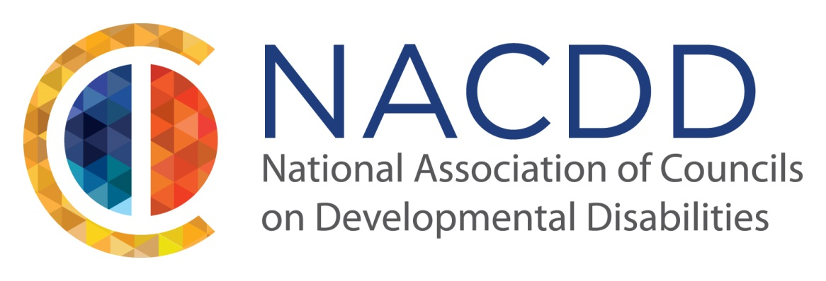

July 21st – 22nd 2015
JA Nugget Resort
Sparks, Nevada

A proposal to the National Association of Councils on Developmental Disabilities (NACDD) Annual Conference 2015
svega@nacdd.org

Presented by Robert F. Reuss

Impacting Communities Side-by-Side

Proposal Submission Guidelines

Please include the information below. Incomplete submissions will not be considered.

Proposer Contact Information
First Name/Last Name Robert Reuss
Mailing Address 1244 Carville Dr. #207
Reno, NV 89512
Phone/Fax/Email (775) 690-5901/ /rreuss@charter.net
Title Self-Advocate
Affiliation Self

Title of Proposed Session: Integrating Nevada Vocational Rehabilitation with the
Local DD Community – A Client Perspective

Objectives (3 things attendees will learn):
Learn about Vocational Rehabilitation in regards to:
- The immediate interaction needs of DD people
- Needed medium and long term reforms
- How to enact reforms (through leadership positions on councils, legislature actions, grassroots activism, etc.)

Description of proposed session (this will be used as the description in the final program)
Include the following:
- Why this session is important
- How it is relevant to the theme of the conference
Impacting Communities side-by-side

Please indicate if the proposed session features leadership strategies and information, in-depth information on a specific topic, or is geared toward self-advocates taking action.

This presentation will continue from my presentation at this year’s Nevada State Disabilities Conference: “Break Open the Doors to Employment with Nevada Vocational Rehabilitation – A Client Perspective”. The focused which is on the individual in the Nevada Vocational Rehabilitation system. This presentation at the National Conference will be focused on reforming the Vocational Rehabilitation system to better meet the needs of those with mental differences.

Self-Advocates must take leadership roles to ensure DD people have the same access, rights, and opportunities as other citizens. Self-advocates empower the DD Community to have control of their own lives.

Empowerment means reforming statewide public policy to address awareness, acceptance, and availability of appropriate services throughout a DD person’s lifetime.

Empowerment means passing legislation that can create extraordinary changes in a person’s well-being, e.g. mandating insurance coverage for the treatment of ASD.

Empowerment means changing the culture of government support services and to make their employees culturally competent to provide support, information, and assistance to the DD Community.

Full bios for each presenter (for inclusion in final program)

In 1998 he came to Reno to pursue a graduate degree in geology. Change to computer science in 1999 after failing to find a thesis advisor within the geology department. Drop out of the computer science master program in 2009 with only the thesis left to finish.

Did a one year course in Reno street life (homelessness) 2009 – 2010. A census job and engineering internship in the summer of 2010 allowed him to find housing. Then followed multi-year training in Reno social services (public assistance) and Nevada Vocational Rehabilitation services. Now a dedicated self-advocate.

Diagnosed with Aspergers in 2005 by Dr. Miller at the UNR Student Health Center. Became a Nevada Vocational Rehabilitation client in 2009 with an employment goal of computer programmer. Currently a client of NNAMHS and NVR.

