Accessibility 101 Quick Tips
  - Ways to make your information more accessible:

Text/Word Documents
- Ensure your documents are properly named in the properties section
- Use built-in formatting features for spacing, headings, paragraphs, line breaks, styles and paragraph formatting
- Use the Navigation pane to check proper heading and content order
- Use bulleted lists
- Use tables for data
- Add alt text to any images or graphics and ensure they are formatted in line with text
- Use sans serif fonts and limit the amount of fonts in one document
- Use meaningful hyperlinks instead of “click here” or “learn more”
- Ensure sufficient contrast between font and background
- Avoid using large blocks of capital letters
- Avoid using a lot of jargon or acronyms unless you provide definitions
- Don’t use color, or other visual aids alone to convey meaning
- Use the accessibility checker built into most word software

PDF’s
- Scanned PDF’s are not accessible, text PDF’s can be made accessible in Acrobat
- Add alt text to any images or graphics
- Ensure the document follows the correct reading order
- Ensure documents are properly named in the properties section
- Use the accessibility checker in Acrobat
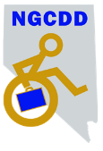Nevada Governor’s Council on Developmental Disabilities

Email
- Use built-in formatting features for spacing, headings, paragraphs, line breaks, styles and paragraph formatting
- When attaching PDF’s or other visual content, include a text summary in the body of your email with details, dates, times, etc.
- Add alt text to any images or graphics
- Don’t rely on visual aids alone to convey meaning
- Use high contrast colors & San serif fonts
- Use meaningful hyperlinks instead of “click here” or “learn more”
- Use your server’s online help tool for accessibility features and corrections

Websites
- Keep it simple, avoid a cluttered look for ease of navigation
- Choose titles that are short, clear and concise
- Keep page headings in chronological order
- Add alt text to any images or graphics
- Ensure images or graphics are formatted in line with text
- Provide captions on videos. Use YouTube and edit what they miss
- Ensure sufficient contrast between font and background
- Use San serif fonts
- Look for built in accessibility features your site may already have
- Use the Web Content Accessibility Guidelines (WCAG) and Accessibility Checker
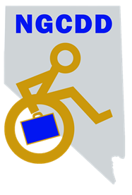Nevada Governor’s Council on Developmental Disabilities
Please note this document is for general reference purposes only. It does not represent all measures to ensure full compliance with state or federal accessibility requirements. Please visit our website www.nevadaddcouncil.org for our Accessibility 101 page, which provides additional information and website resources.

