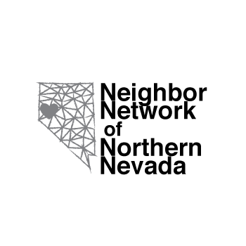

Neighbor Network of Northern Nevada (N4)

Transit Planning 4 All

Increasing inclusion in transportation planning and services for people with disabilities, older adults, and their care partners.

Final Report
January 2019

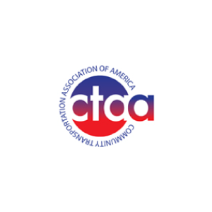
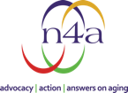
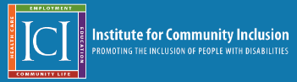
N4 Transit Planning 4 All

Increasing inclusion in transportation planning and services for people with disabilities, older adults, and their care partners.

The Neighbor Network of Northern Nevada would like to thank all of the community members and partner organizations who made this project possible. Through the contribution of your knowledge, experience, and ideas, we have been able to take steps toward making the transportation planning process more inclusive for people living in Washoe County.

This project was funded by a grant from the Administration for Community Living of the United States Department of Health and Human Services. The Community Transportation Association of America in partnership with the National Association of Area Agencies on Aging and the Institute for Community Inclusion of the University of Massachusetts-Boston administered the project.
TABLE OF CONTENTS

INTRODUCTION 4
N4 TRANSIT PLANNING 4 ALL 5
TIMELINE AND ACTIVITIES: PHASE 1 “HEAR” 7
Steering Committee Creation, Organization, and Activities 7
Engagement Activities 13
Convening I 13
TIMELINE AND ACTIVITIES: PHASE 2 “CREATE” 14
Analysis, Updating, and Continued Community Engagement 14
Focus Group 15
Theme Analysis 18
Convening II 20
Theme Analysis 22
INTERVIEWS, SURVEYS, AND DATA ANALYSIS 24
Participant and peer-to-peer interview data and analysis 24
Theme Analysis 26
Community Survey Data 28
RECOMMENDATIONS 39
Themes, solutions, and prototype concepts 39
CONCLUSION 43
Future Goals 44
Endnotes 45
Community Survey 45
Participant and peer-to-peer interview questions 51

INTRODUCTION

The Neighbor Network of Northern Nevada (N4) connects people living in Northern Nevada for inclusive, community-based services, volunteer opportunities, and affordable transportation.

N4 was initially developed in 2015 as part of a National Center for Mobility Management “Rides to Wellness” design grant intended to help older adults and people with disabilities have better access to healthcare. By conducting community outreach, surveys, and focus groups, N4 studied potential transportation innovations. It was determined that the community village model, with a time exchange program, was the most desirable and feasible solution, as it allowed for both the receiving and contribution of services for members. N4 subsequently received multiple grants from the Nevada Governor’s Council on Developmental Disabilities (NGCDD), Nevada Aging & Disability Services Division, and the Federal Transit Administration’s 5310 program that have allowed for the recruitment of more people with disabilities and older adults into N4’s transportation programs.

The N4 time exchange transportation project aims to create a pool of drivers who are interested in helping members with various types of transportation needs including rides to medical appointments, social/recreational rides, errands, rides to work, and more. When someone has a transportation need, N4 staff matches them with an available driver. Drivers earn time exchange hours for their time spent providing rides. Hours earned are then exchanged for a variety of other services from other time exchange members.

In addition to the time exchange, N4 operates a “volunteer village” where community members are connected to each other and partner organizations for fulfilling volunteer opportunities, including giving rides. For the past two years, N4 has piloted an innovative new program, N4 Connect, in collaboration with the shared ride company, Lyft. N4 Connect is designed to provide a means for people to access more affordable transportation options by offering discounted Lyft rides. People with disabilities and/or adults over the age of 60 can receive up to $160 worth of Lyft rides for only $40 per participant each month. If a participant does not have a smartphone, or needs help scheduling a ride, the N4 Connect concierge option allows them to contact an N4 team member to schedule the ride for them. Coming in Spring 2020, N4 will be purchasing a wheelchair accessible van to utilize as an N4 Connect accessible vehicle to expand the shared ride program.

N4 TRANSIT PLANNING 4 ALL

The N4 Transit Planning 4 All (TP4A) project gathered the information needed to help facilitate the development of local inclusive transportation systems in which people with disabilities, older adults, and care partners actively participate in the transportation planning process in both advisory and decision-making capacities. The overarching goal of this project was to advance the local community in Northern Nevada on the Pathway to Inclusion.

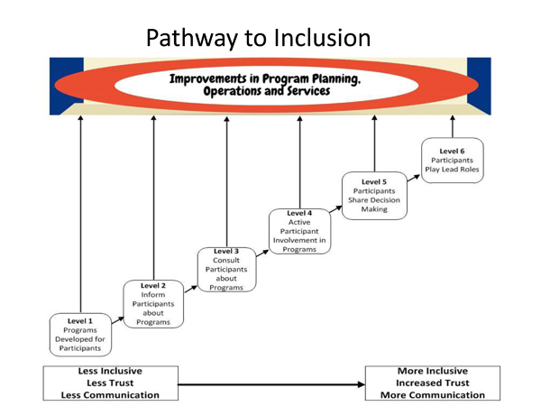
Figure. 1 At the beginning of the TP4A project, on average, stakeholders rated their local community at
Level 3 - Consults participants about programs.

Project Framework

Human-centered design

Human-centered design (HCD) is a way of thinking, as well as a guiding framework for program design, that facilitates the creation of solutions to problems by including the people those solutions are intended for in the problem-solving process. A core component of an HCD project is the inclusion of participants in leadership roles that involve the assessment of needs and current assets, the brainstorming of potential solutions, and feedback at project completion.

Timeline and activities

The three stages of human-centered design are “Hear,” “Create,” and “Deliver.” The N4 TP4A project was designed as two phases, the “Hear” phase and the “Create” phase. The completion of the first two HCD phases is intended to help guide the development of a future “Deliver” phase.

The goal of the “Hear” phase (Phase 1) was to listen to older adults, people with disabilities, and their care partners about their experiences with transportation and transit planning in Northern Nevada. Activities in Phase 1 included a community convening, participant and peer-to-peer interviews, a community survey, and participation in numerous outreach events.

The “Create” phase (Phase 2) was designed to explore and begin drafting possible solutions for the transportation and transit planning problems collected during Phase 1, and to continue listening to and interacting with the community, especially in terms of their thoughts regarding potential solutions. Activities included a second community convening, a focus group, and continued interviews and surveys.

TIMELINE AND ACTIVITIES: PHASE 1 “HEAR”

Steering Committee Creation, Organization, and Activities
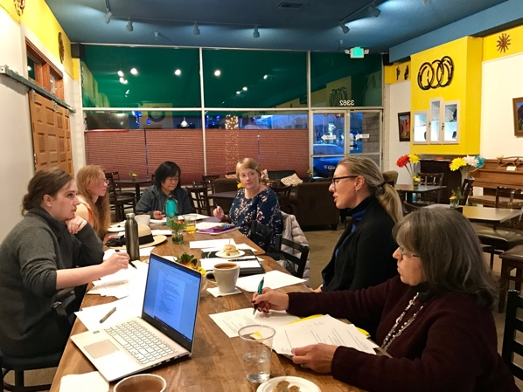
The initial activity undertaken for this project involved the recruitment of individuals and partner organizations to serve on a steering committee. The steering committee guided planning and decision making, the creation of materials, the design of the methods of data collection and analysis, activities to engage the community, and outreach activities and materials. They also reviewed grant project information, information about upcoming events, and data from distributed materials. All steering committee members also pledged to complete at least two in-person peer-to-peer interviews, in-person surveys, and to distribute surveys to relevant populations. Monthly steering committee-specific satisfaction surveys were used to gather information to improve subsequent meetings.
Image 1. N4’s Transit Planning 4 All steering committee meetings.

The steering committee meetings were made accessible by ensuring meetings were held close to bus lines in central locations. Members of the steering committee were also polled in order to assess the best time to hold the meetings. Members in need of transportation to and from meetings were provided with free, roundtrip Lyft rides.

Steering committee composition

Individuals on the steering committee included older adults, people with disabilities, and care partners. The steering committee also included representatives from organizations that serve older adults, people with disabilities and care partners, as well as a representative from the regional transportation agency.

Table 1. Stakeholders on steering committee.
Type | Number (across all meetings) | Name
Person with a disability, older adult, and/or care partner | Average: 7.6; Range 6-10 | n/a
Representative from regional transportation agency | 2 | - Regional Transportation Commission (RTC)  - Sierra Nevada Transportation Coalition (SNTC)
Representative from organization serving older adults | 4 | - Seniors in Service  - UNR’s Sanford Center for Aging  - Northern Nevada Center for Independent Living (NNCIL)  - The Continuum
Representative from organization serving people with disabilities | 7 | - Northern Nevada Center for Independent Living (NNCIL)  - Sierra Regional Center (SRC)  - The Continuum  - Nevada Center for Excellence in Disabilities  - Nevada Governor’s Council on Developmental Disabilities (NGCDD)  - National Federation for the Blind  - Spina Bifida Association
Representative from organization serving care partners | 1 | - The Community Foundation of Western Nevada

Steering Committee Activity 1: Creation of project timeline, activities, and materials

The first priorities of the steering committee were the establishment of a timeline for the project, the development and planning of activities and events, and the creation of materials to be used during the extent of the grant period.

Activities designed to run throughout the project included a community survey and participant and peer-to-peer interviews.

The primary Phase 1 (July - September 2018) activity was a community convening (September 19, 2018). Phase 2 (October 2018 – January 2019) activities included a focus group (November 16) and a second community convening (December 7).
See endnotes for community survey and interview questions.

Steering Committee Activity 2: Design of methods for data collection and analysis

In order to design appropriate methods of data collection and analysis, best practices for fieldwork-based materials and data collection were researched, discussed, and decided on by the steering committee. The primary issues addressed in terms of data collection involved the accessibility of materials and the methods used for distributing materials.

Methods for data analysis were developed for the two distinct data sets that were collected: quantitative and qualitative data. First, it was decided that the simplest and most easily-displayable methods of analysis and data presentation were to be used for quantitative data in order to ensure its inclusivity and accessibility. For narrative and qualitative data, coding (which enables theme analysis) was chosen as the primary method for data processing. Coding is elegantly summarized by Johnny Saldana’s “Coding Manual for Qualitative Researchers:”

“A code in qualitative inquiry is most often a word or short phrase that symbolically assigns a summative, salient, essence-capturing, and/or evocative attribute for a portion of language-based or visual data... Just as a title represents and captures a book or film or poem’s primary content and essence, so does a code represent and capture a datum’s primary content and essence.” (Saldana 2008)

Steering Committee Activity 3: Identification of solutions to potential barriers

The steering committee next worked to identify potential barriers and develop solutions to them before issues were encountered. These solutions included:

- Hosting all meetings in ADA compliant, easily accessible areas
          - Gathering information about additional needs of participants and making appropriate accommodations
          - Providing transportation assistance to and from meetings
          - Ensuring the accessibility of written and electronic materials
          - Translating materials
          - Making available a translator for in-person interviews

Steering Committee Activity 4: Outreach design and implementation

The steering committee guided the process of, created materials for, and designed distribution methods for the outreach undertaken during the extent of the TP4A project. Participant outreach was designed to target older adults, people with disabilities, and care partners. Organizational partnership outreach was designed to prioritize building relationships with Regional Transportation Commission (RTC) and relevant state and county agencies with decision-making power in the hopes that engaging these groups might yield a greater understanding of the path to inclusion and augment the ability to begin implementing new projects at the end of the grant period.

Table 2. Outreach method and implementation.
Outreach Method | Outreach Implementation
Presentations to and attendance at public meetings that included neighborhood representatives and public officials in order to introduce the project, recruit additional partners and participants, and present findings | - Presentation at Sierra Regional Center  - Presentation at the Community Foundation of Western Nevada Caregiver Support Network Initiative and monthly steering committee meetings  - Participation in monthly Dementia Friendly Washoe County initiative meetings  - Participation in Dementia Friendly subcommittee meetings for the neighborhood, business, and retail sectors  - Participation in RTC’s ADA Transition plan update stakeholder meeting  - Presentation to local group of community disability service providers  - Presentation to Sierra Nevada Transportation Coalition’s executive board  - Participation in a discussion panel for transportation-outlying area to discuss transportation options for older adults  - Meeting with Family Support Council (rural support organization) to discuss their transportation program and service delivery philosophy  - Attendance at Northern California/Northern Nevada Alzheimer’s Association’s Open House  - Meeting with Nevada Lifespan Respite Care Coalition
Meetings with county, state, and regional representatives | - Meeting with Washoe County Commissioner Kitty Jung and the Communications Director for the office of the County Manager to discuss the project and build connections with other organizations and representatives including the County Human Services Marketing and Public Relations Coordinator, RTC’s board members and PR department, and other commissioners  - Meeting with public information officers and planning administration staff from RTC and Washoe County Human Services regarding press releases, news articles, and TV/radio appearances  - Meeting with Sanford Center for Aging and State of Nevada Aging and Disability Services Division administrators  - Meeting with Nevada Governor’s Council on Developmental Disabilities regarding the development of a steering committee to plan a transportation summit in the Spring of 2019  - Participation in a State of Nevada Division of Healthcare Finance and Policy meeting regarding Medicaid-funded non-emergency medical transportation
TV and radio interviews | - Interview on KOLO8 “The Road Ahead”  - Interview on Senior Spectrum’s ‘Editor’s Desk’ (local senior radio show)
Direct mail outreach | - RTC ADA Eligible contact database  - N4 member database  - SNTC member database
Social media outreach | - Regular posts, events, pictures, and reminders of all related activities and relevant materials
Website outreach | - Regular blog and event posts
Flyer posting | - RTC ACCESS vans (paratransit)  - Transit stations  - Various community locations including:  - Locations accessible by bus route and paratransit services  - Outlying areas not served by public transit
Tabling events | - What Can I Do?  - 39 North Marketplace  - Renown (local hospital) Volunteer Fair  - PumpkinPalooza 2018 (a local Fall community event/fundraiser for people with disabilities)  - Diversity Fair at Northern Nevada Muslim Center  - Senior Health Fair (in conjunction with RTC)
Email outreach | - Survey and other information distributed to partner organization and N4 mailing lists

Steering Committee Activity 5: Community engagement

The next, and perhaps most important, work of the steering committee involved bringing together community members to foster dynamic conversation about what works and what needs improvement in transportation services and the transit planning process. This process was designed to facilitate opportunities to truly listen to the community and collaborate with them in order to collect valuable data. To accomplish this, participant and peer-to-peer interviews were conducted, a community convening was held, and a community survey was distributed.

Engagement Activities

Convening I
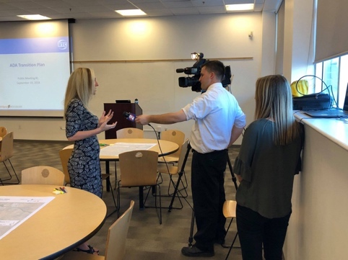
Image 2. N4 Executive Director interview at N4 and RTC Open House
The first convening of this project, the N4 and RTC Open House, was held on September 19 at the Discovery Museum and was attended by 40 participants. The convening was designed and facilitated collaboratively by N4 and RTC and involved small group discussions, a directed large group conversation, a presentation from N4’s Executive Director, and a tabling session. During the open house, both the Transit Planning 4 All project and RTC’s ADA transition plan were reviewed and discussed. At the end of the event, surveys were distributed and interviews were conducted with attendees. Prior to the convening, the steering committee implemented a variety of outreach activities and analyzed their effectiveness in order to enhance outreach for subsequent activities.

TIMELINE AND ACTIVITIES: PHASE 2 “CREATE”

Analysis, Updating, and Continued Community Engagement

Steering Committee Activity 1: Analysis

The initial activity of Phase 2 was the analysis of findings from the “Hear” phase. The steering committee reviewed and analyzed data, including emerging themes from surveys, interviews and Convening I reports, and shared what they had learned about the preferences and perspectives of participants. The steering committee then created an updated framework for methods of distributing materials, design and organization of community engagement events, and outreach strategies for subsequent activities.

Steering Committee Activity 2: Continued community engagement

Using the updated frameworks, the steering committee continued listening and brainstorming with participants to verify and expand on prominent themes from the “Hear” stage of the TP4A project. Engagement activities included a focus group and a second convening, as well as the continuation of participant interviews and surveys.

Steering Committee Activity 3: Final compilation and analysis of data

The steering committee’s final activity was the compilation and analysis of the data collected during the project. Following analysis, this final, comprehensive report was generated that includes recommendations for future solutions and their implementation.

Engagement Activities

Focus Group

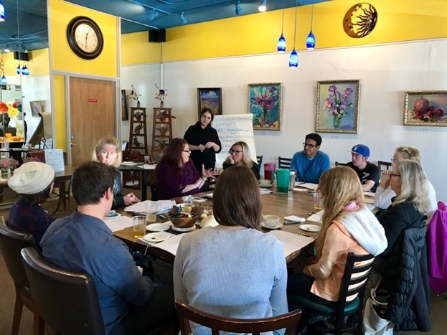
The Phase 2 focus group was designed and facilitated by the steering committee to provide the community an opportunity to share their experiences in transit planning and transportation services, while also exchanging innovative ideas related to improving the shortfalls of transit planning and gaps in transportation services in Washoe County. The focus group, or “Community Conversation,” was a collaboration between 12 community members, including 3 older adults, 4 people with disabilities, and 4 care partners. Participants also included representatives from local provider organizations.
Image 3. N4’s “Community Conversation”

Before presenting and discussing narrative questions, each participant provided the following contextual information:

          - Types of transportation used:

• Public transit
• Medical transit
• Rideshare
• Personal/care partner/support staff
• Bicycle/Walking

          - Purposes of transportation used:

• Work
• Groceries/shopping
• Educational obligations
• Medical appointments
• Recreational/social activities
• Church

          - Points of contact for those who have reached out for help regarding transportation needs:

• Personal/care partner/support staff
• Community organizations (N4, Sierra Regional Center)
• City of Reno
• School District
• ACCESS (paratransit)/Medicaid
• Lyft/Uber/Taxi Bucks
• RTC

          - Persistent issues that have remained unmet, even after participants reached out to relevant transportation contacts:

• Technological barriers
• Accessibility
• Not knowing resources
• Transit Anxiety
• Inefficiency

Following the collection of contextual information, the focus group discussion centered on participants’ transportation needs that had not been met. Based on the narratives that the attendees shared, accessibility, affordability, unreliable transit, transit anxiety, logistical concerns, and technological barriers were found to be the predominant needs (Table 3).

Table 3. Which of your transportation needs have not been met?

As in participant and peer-to-peer interviews, the factors that are barriers for voicing opinions, thoughts, and ideas regarding transportation were discussed. In general, participants addressed barriers that fell under the themes of technological difficulty, advocacy, futility, inefficiency, transit anxiety, and not knowing ones’ resources (Table 4).

Table 4. What barriers do you face when it comes to voicing your opinions, thoughts, and ideas about transportation?

Next, participants discussed what they envisioned in terms of creative improvements in transportation services and the transit planning process. Participants discussed topics including accessibility, affordability, streamlined technology, safety, advocacy, and community involvement (Table 5).

Table 5. What improvements in transportation services/the transit planning process do you envision?

Finally, participants discussed how the transit planning process could be made more inclusive/accessible. Their innovations included:

• Increase accessibility via regular schedule of meetings/focus groups
• Overcome semantics
• Create reliable/resourceful sharing of information
• Utilize social media and get information out there

After generating codes to represent all of our narrative focus group data, certain themes became clear. These themes are as follows:

• Accessibility
• Affordability
• Unreliable transit
• Transit anxiety
• Logistical concerns
• Not knowing resources
• Futility
• Technological barriers/streamlining technology
• Advocacy
• Safety
• Community involvement

Theme Analysis

The codes listed above, within each table, can be referred to for more insight into the specific points encompassed by each theme. The following analysis is selective, focusing on themes which offer more insight into the inclusivity of the transit planning process.

Advocacy

The focus group demonstrated that advocacy is a major theme for transit planning improvement. As one representative from a local organization stated, “Gestures can speak even more than words; stand up for this, literally, even if you can’t speak up.” Beyond more extensive and representative voting power, or board membership, participants in the focus group emphasized public gestures as a way of advocating for more inclusive transit planning.

Safety

Safety of public transit, and the improvement thereof, was suggested as a priority for future transit planning. With increased safety of transportation, stigma and trepidation surrounding public transit could potentially be reduced.

Streamlined Technology

For the greater inclusion of older adults, people with disabilities, and their care partners, the focus group mentioned that streamlining technology must be prioritized in transit planning. Transit apps were specifically called out for being too inaccessible and often inconsiderate of the specific needs of certain individuals.

Community Involvement

A widely discussed idea within the focus group was to get the community as a whole engaged in the push for greater transit planning inclusivity. With the mindset that inclusivity goes both ways, that we need to “include the general community and engage them in things that people with disabilities depend on,” focus group participants came up with ideas to promote the experience of transit, to individuals and businesses alike, thereby encouraging more productive and considerate transit planning.

Reliable/Resourceful Sharing of Information

As mentioned within the focus group, the need to establish a system of reliable and resourceful information sharing is strong. In fact, a major barrier to voicing ideas for transit planning, as outlined in Table 4, is “not knowing resources.” People are unsure of who to contact with their transit concerns and ideas, they don’t feel as though they have the appropriate contacts, or even the means to contact appropriate sources. Steps toward bettering this system of information sharing might involve overcoming semantics (essentially overcoming the psychological barriers of communication), utilizing social media more tactfully, and so on.

Accessibility

While there are many facets to accessibility in transportation and transit planning, the theme was much discussed in the focus group and was occasionally reviewed in terms of the inclusivity of transit planning specifically. For transit planning in particular, one innovation was to increase the accessibility of the planning process by establishing a regular schedule of meetings and focus groups. Participants also mentioned that an expanded scope of transportation and physically accessible transportation would allow for greater attendance to such meetings.

Convening II
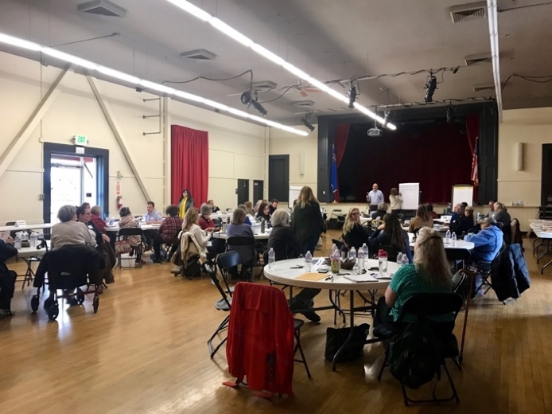
For the second convening, N4 collaborated with the Sanford Center for Aging on their "Speak Up, Be Heard" Community Gathering to assess the relationship between social engagement and transportation, and in the process discover more about the inclusivity of transit planning. A variety of different stakeholders within the community attended the event.

Out of the 56 total attendees, 24 were people with disabilities, older adults, or care partners. Small groups were designated for more intimate conversation, making up 9 tables total, however, periodically everyone shared main ideas with the convening as a whole. 20 survey responses were obtained from attendees at the Community Gathering for the Transit Planning 4 All Project.
Image 4. N4’s second convening, in partnership with Sanford Center for Aging, was promoted as an event called “Speak Up, Be Heard.”

This convening’s main questions contextualized transit and transit planning with social engagement. Relevant responses from these questions were selected. One question posed to the convening asked about barriers that might prevent people from doing activities that they enjoy. Thematically, many of the barriers fell under unreliable transit, accessibility, social concerns, affordability, health, logistical concerns, transit anxiety, technological barriers, unknown resources, and safety concerns (Table 6).

Table 6. What are the barriers that might prevent you from doing activities that you enjoy doing now?

In the final question, innovative ideas and strategies to increase social engagement were discussed. For the sake of this report, all transit related answers were reported. From these answers, community involvement, streamlined technology, affordability, advocacy, accessibility, and reliable/resourceful information sharing were prevalent themes (Table 7).

Table 7. What are your innovative ideas and strategies to increase social engagement for you?

As with the focus group, all of the narrative data collected from this activity was organized into sets of codes, with themes arranged from these sets:

• Unreliable transit
• Accessibility
• Social concerns
• Affordability
• Health
• Logistical concerns
• Transit anxiety
• Technological barriers/streamlining technology
• Not knowing resources
• Safety concerns
• Community involvement
• Advocacy
• Reliable/resourceful information sharing

Theme Analysis

The following themes are discussed in relation to transit planning. While the second convening was largely focused on exploring the connection between social engagement and transit, many of the themes overlapped with N4’s inquiry into transit planning. Certain unique points were made in the convening’s narratives, however, that distinguished the details of these themes from those already explored in the focus group.

Accessibility

Discussing barriers to community engagement established insight into the shortcomings of current transit planning. One such barrier, thematically, was accessibility. Difficulties with transit accessibility were largely discussed (geographical accessibility, vehicular, and so on) and, as a recurrent part of the convening’s conversation, made evident the disconnect between people’s needs and transit services, a disconnect that would likely benefit from more appropriate transit planning.

Streamlining Technology

As one participant in the convening mentioned, “connecting drivers with riders” is critical for older adults and people with disabilities. This connection is often only possible via technology; and when technology is not navigable for certain individuals, these connections are lost. In future transit planning, a greater understanding of what is necessary to optimize technology for certain populations within the community is needed. Future transit planning, to gain such an understanding, would benefit from the inclusion of these populations in the planning process.

Community Involvement

While community involvement was brought up in a discussion similar to N4’s focus group, a unique suggestion made at the convening was to prioritize the collaboration between existing, local organizations in order to more effectively progress engagement with the community, often by means of local transportation services. Transit planning would benefit from involving organizations and promoting cross-collaboration.

Advocacy

Participants emphasized the idea of self-advocacy as an important part of overcoming barriers to engagement. Creating more advocacy programs, outlets for communicating needs, and organizing groups with the purpose of increasing social engagement, many times with the goal of bettering transit, was integral for many of the participants. Advocating for the importance of social engagement and finding outlets to creatively advocate transit services that actually incorporate the recreational needs of individuals was a key discussion point.

Reliable/Resourceful Information Sharing

Participants expressed a variety of suggestions for improving engagement; suggestions which all fell under the larger concept of information sharing. Utilizing and expanding on existing resources, as it turned out, was the innovative solution put forward by participants. From creating a one-stop-shop of all transit-related resources to taking advantage of existing bulletin boards, multiple ideas came together to support information sharing, as you can see in Table 7. Through thorough and resourceful information sharing, more involvement in the transit planning process can be established.

INTERVIEWS, SURVEYS, AND DATA ANALYSIS

Participant and peer-to-peer interview data and analysis

14 interviews in total were completed over the 7 months of this project. These interviews were completed across multiple locations, often at the discretion of the interviewee. Preliminary demographic questions helped to identify and confirm the participation of a wide representative sample of Washoe County’s population. In total 4 older adults, 3 care partners, 10 individuals with disabilities, and 3 Hispanic individuals completed interviews (interviewees were permitted to identify themselves with as many characteristics as they felt were applicable). Of the interviewees, 9 had not participated in transit planning before. Following the interview, 8 interviewees expressed interest in participating in transit planning in the future.

Qualitative and narrative data

Both the design of the interview questions and the method for analyzing the collected data were completed using coding. The interviews also included contextual questions, which were organized with basic coding, although not analyzed for themes. As such, the following data progresses from non-narrative, contextual questions, to the codes and themes drawn from narrative and more in-depth analysis.

          - Primary mode of transportation:

• Personal/care partner/support staff
• Rideshare
• Public transit
• Medical transit
• Bicycle/Walking

          - Interviewees typically access transit information via these general points of contact:

• Online
• RTC
• Word of mouth
• Personal/Care partner/support staff
• City of Reno
• ACCESS (paratransit)/Medicaid
• Community organizations (N4, SNTC…)
• Media (tv, radio, newspaper, notices in transit vehicles…)

The first narrative question offers insight into the barriers that interviewees encounter when attempting to voice their opinions, thoughts, and ideas regarding transportation. Major barriers across all the interviews, which have been organized into themes, include transit anxiety, inaccessibility, inefficiency, futility, and not knowing resources (Table 8).

Table 8. What factors are barriers for you to voice your opinions, thoughts, and ideas regarding transportation?

Interviewees were then asked about their biggest concern regarding transportation issues in Washoe County. Thematically, major concerns revolved around safety, unreliable transit, reliable/resourceful information sharing, affordability, accessibility, inefficiency, and futility (Table 9).

Table 9. What are your biggest concerns regarding transportation issues in Washoe County?

The interview was then opened to participants to voice any additional comments regarding transit planning in Washoe County. Interviewee comments revolved around related themes including community involvement, responsiveness, unreliable transit, technological barriers, advocacy, and reliable/resourceful information sharing (Table 10).

Table 10. Do you have any other comments regarding transit planning in Washoe County?

Based on the codes generated from reviewing all of the narrative interview data together, a set of overarching themes were identified. These include:

• Transit anxiety
• Inaccessibility/Accessibility
• Inefficiency
• Futility
• Not knowing resources
• Safety
• Unreliable transit
• Reliable/resourceful information sharing
• Affordability
• Community involvement
• Responsiveness
• Technological barriers
• Advocacy

Theme Analysis

The interviews revealed themes that tend to compound those revealed by our focus group and convening activities. Despite the overlap, novel solutions were still suggested, and transit concerns were often framed to inform potential solutions.

Futility and Responsiveness

Feelings of futility were prevalent among our interviewees. Not only were interviewees testifying that they were feeling as though their voices would not be heard (Table 9), one interviewee mentioned that they have been explicitly told by other members of the community that their voice will not create change. As another individual with a disability explained, “They hear the words, but aren’t listening,” referring to public transit agencies. Other interviewees expressed frustration at seeing no response to the attempts they’ve already made at being involved in transit planning. Largely, this led to a discussion of responsiveness. Responsiveness ended up being suggested as a remedy to transit planning that is unreceptive or not inclusive.

Community Involvement

Similar to what was discussed at the focus group, a few interviews revealed that people believe community involvement is necessary in order to make transit planning more inclusive. According to a care partner, “You need to invite people to be included, you have to create a buy-in, and there has to be skin in the game so that everyone gets involved.” If a greater emphasis is placed on personal connections to transit, more individuals would involve themselves in the process of planning, and the needs of the community would more accurately be reflected in transit planning and service outcomes.

Advocacy

As a general commentary on the inclusivity of transit planning in Washoe County, some interviewees suggested that more creative advocacy is needed. One interviewee, an individual with a disability, suggested that more citizen advisors, or people with first-hand and long-term experience as both passengers and minorities, need to counsel transit agency management. In this way, personal and accurate assessments of what is needed in transit would be incorporated more thoroughly into the transit planning process. The key, it would seem, is for these advocates to be heard. Relatedly, the importance of qualitative data was also a highlight in a few of the interviews. Considering many people expressed that they felt as though their voices do not matter to larger agencies and planning committees, it was suggested that more importance needs to be placed on narrative and qualitative data, particularly by those agencies. Truly considering qualitative data, not as a formality but as a necessity, would help people feel more included in the transit planning process.

Reliable/Resourceful Information Sharing

A significant way to expand inclusivity, as suggested by interviewees, is to consistently share information and prioritize keeping people in the loop as plans progress. It is often a lack of information sharing, or more precisely a lack of reliable and creative information sharing, that leaves people feeling less involved. Combined with the fact that interviewees stated they often do not know who to go to with their ideas or concerns, or where to get their information, or how to find information, and it becomes clear that information sharing, and the methods thereof, are important to transit users.

Transit Anxiety

A recurring theme in the interviews, as well as every other narrative activity up to this point, was essentially transit-related anxiety. Interviewees stated that they often found it intimidating to speak out about transit, that the entire process of getting involved in transit planning, connecting to appropriate contacts in the field of transportation, and pursuing inclusion, was actually “daunting.” As one interviewee mentioned, the extensive “hoops” they felt they had to jump through to make change happen left them feeling anxious. Similar sentiments were echoed by the focus group: voicing one’s opinion, particularly in public scenarios, and anticipating the entire lengthy process of creating change is daunting overall.

Community Survey Data

The community survey was administered throughout the entire grant period. A total of 85 responses were obtained, including 20 from Convening II. 31% of respondents identified as an older adult, 28% as a person with a disability, and 41% identified themselves as a care partner. The following data is aggregated from all survey responses. Narrative data from long-answer survey questions was used for general coding and to generate specific solutions and prototype concepts.

The primary relevant findings from the survey relate to participants’ sense of their voice being heard and/or valued. In response to the question “I feel like transportation service agencies in Washoe County value my thoughts,” 21% responded ‘Strongly Disagree.’ (Graph 11) In response to the question “Which of the following are barriers for you to voice your opinions, thoughts, and ideas regarding transportation,” over 30% of participants responded, ‘I do not feel my thoughts or opinions will be valued.’ (Graph 14)

Other relevant information gathered indicates that respondents’ primary transportation related concern is ‘Public Bus Route Access,’ (Graph 1) and that their primary method of accessing transportation-related information is ‘Word of Mouth.’ (Graph 3)

Using the information gathered from this survey guided the creation of potential solutions and prototype concepts. It will also help to inform future studies, program enhancements, and new program implementation.

PLEASE NOTE: Graphs were intentionally made large to accommodate those with visual and other impairments. Information, including ranking system and primary response, were listed in the graph title/caption to provide additional information for those using screen readers.

Graph 1. What is your primary mode of transportation? Primary response: Drive car alone.
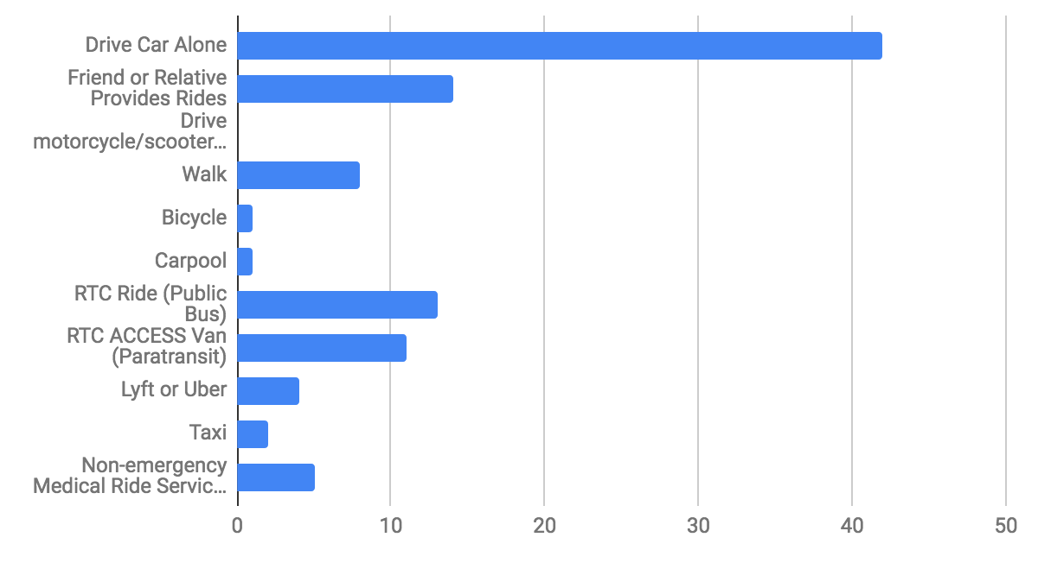

Graph 2. Which transportation issues concern you most? Primary response: Public bus route access.
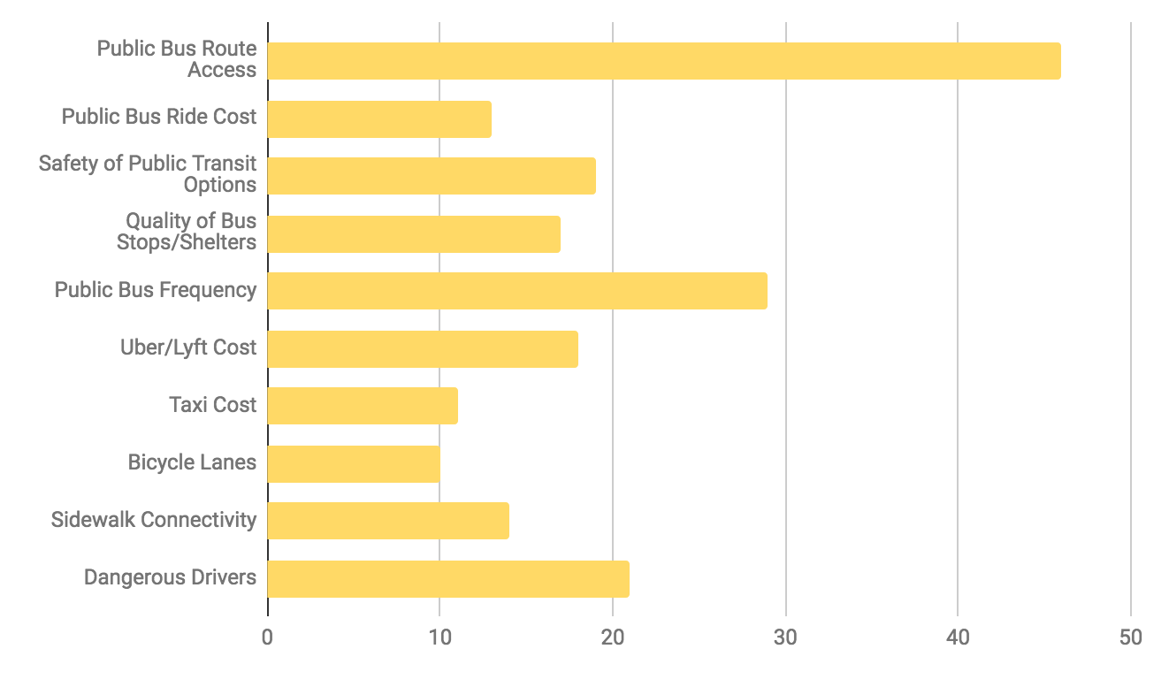
Graph 3. How do you access information about transportation in Washoe County? Primary response: Word of Mouth.
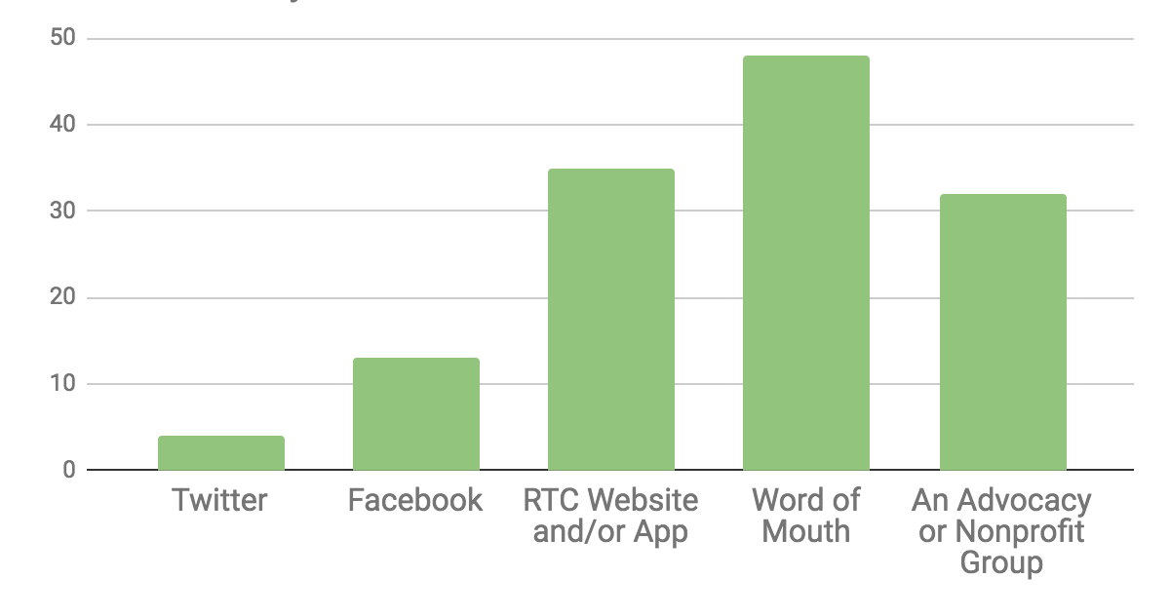

Graph 4. Have you ever participated in any of the following activities related to transportation planning? Primary response: None of the above.
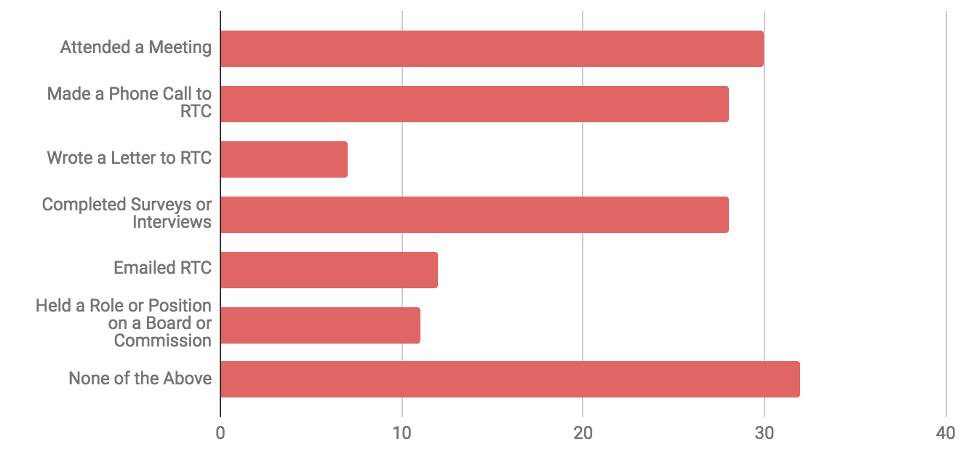

Graph 5. My transportation needs are being met. Ranked: Strongly Agree, Agree, Neutral, Disagree, Strongly Agree, Not Applicable. Primary response: Agree.
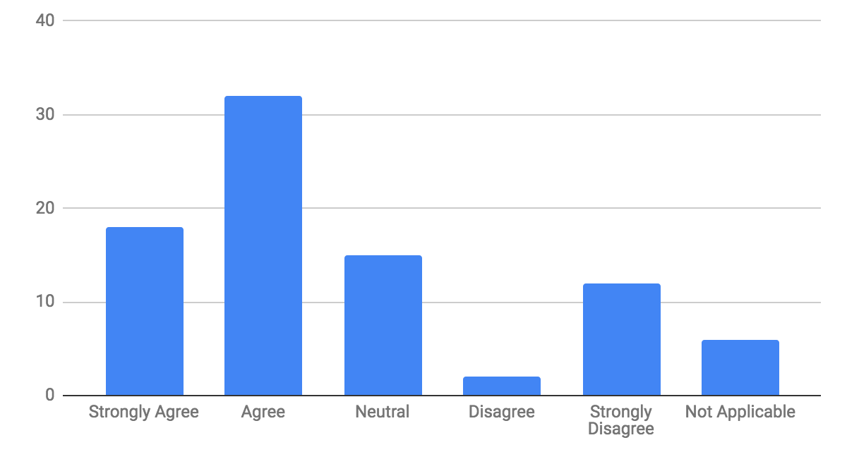

Graph 6. I feel well-informed regarding my transportation option. Ranked: Strongly Agree, Agree, Neutral, Disagree, Strongly Agree, Not Applicable. Primary response: Agree.
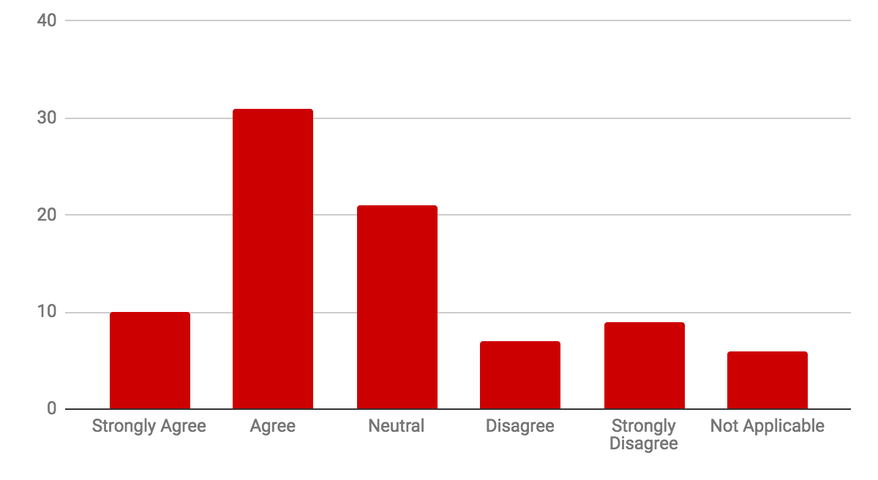
Graph 7. Transit service agencies are responsive to my feedback. Ranked: Strongly Agree, Agree, Neutral, Disagree, Strongly Agree, Not Applicable. Primary response: Neutral.
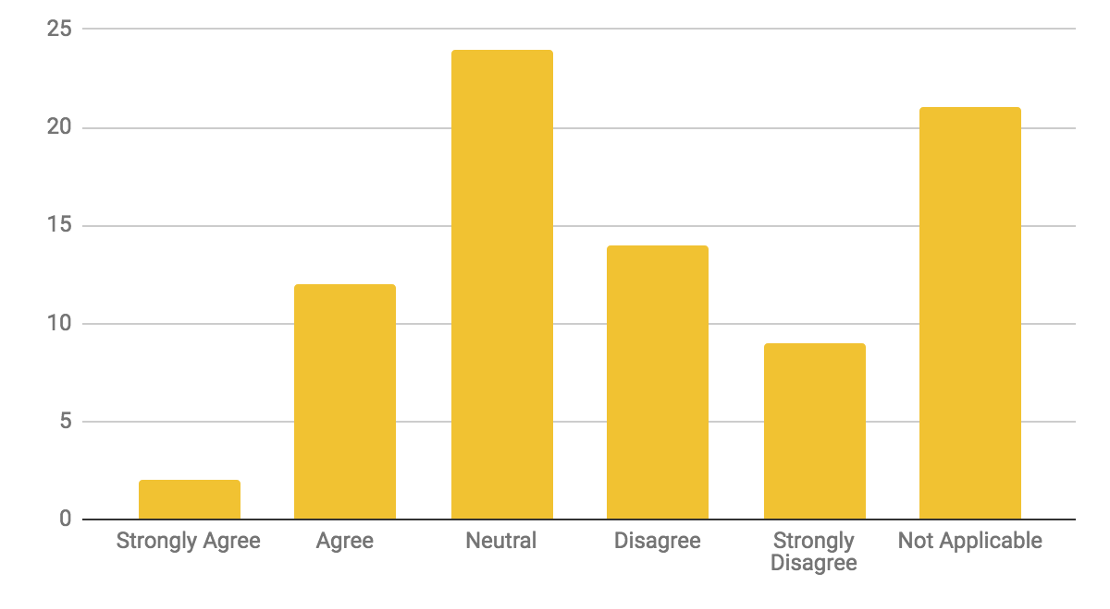

Graph 8. I feel well-informed regarding how transportation planning happens in my community. Ranked: Strongly Agree, Agree, Neutral, Disagree, Strongly Agree, Not Applicable. Primary response: Neutral.
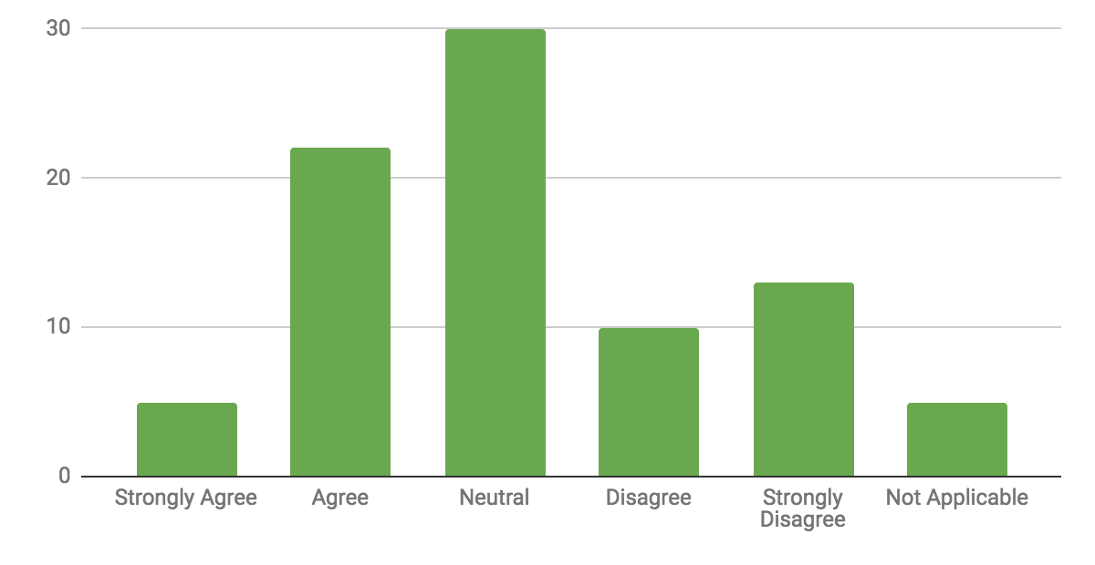
Graph 9. I know how to express my transit needs effectively. Ranked: Strongly Agree, Agree, Neutral, Disagree, Strongly Agree, Not Applicable. Primary response: Agree.
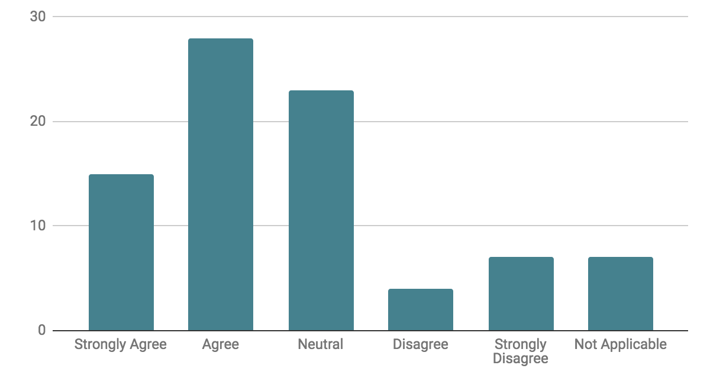

Graph 10. I feel my voice matters in the transportation planning and decision-making process. Ranked: Strongly Agree, Agree, Neutral, Disagree, Strongly Agree, Not Applicable. Primary response: Neutral.
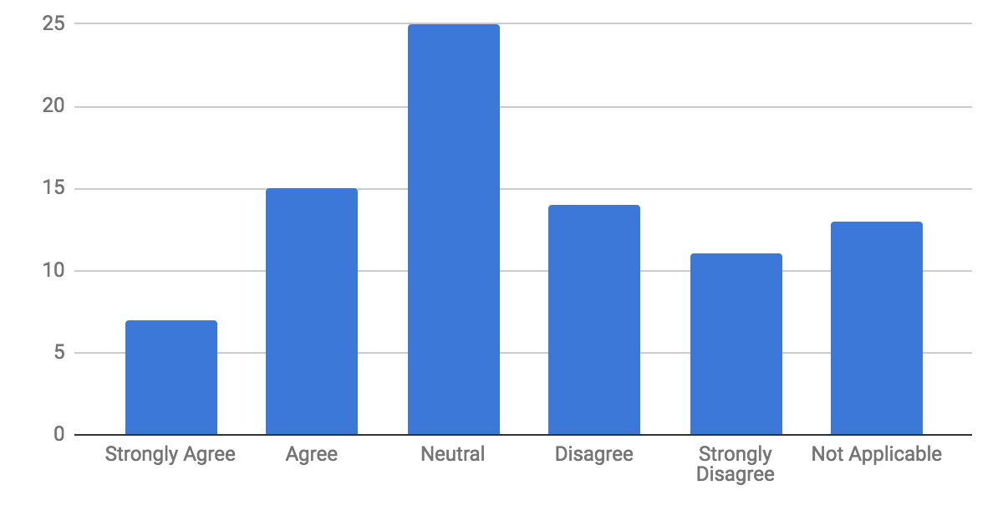
Graph 11. I feel like transportation service agencies in Washoe County value my thoughts and opinions. Ranked: Strongly Agree, Agree, Neutral, Disagree, Strongly Agree, Not Applicable. Primary response: Neutral.
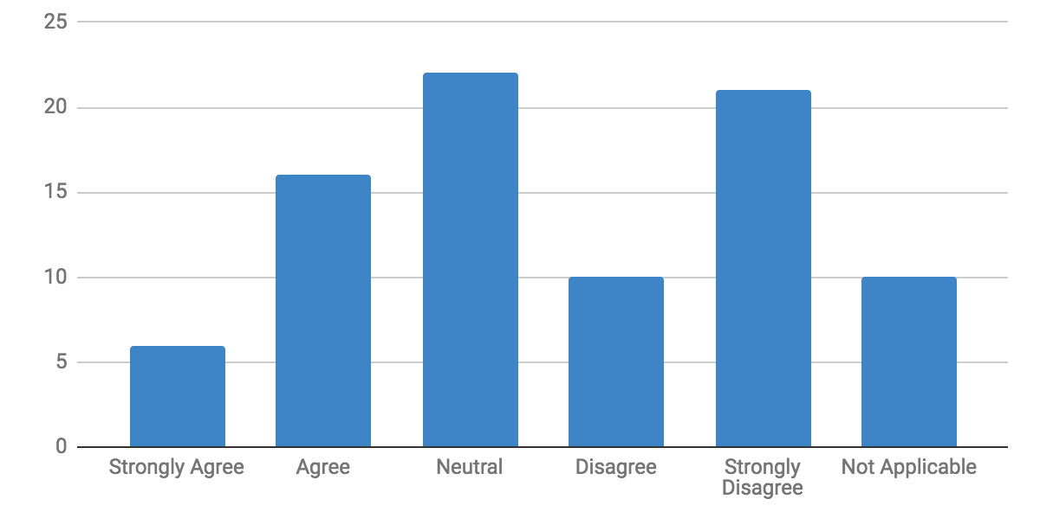

Graph 12. I know who to contact or what agency to contact for help with transportation issues. Ranked: Strongly Agree, Agree, Neutral, Disagree, Strongly Agree, Not Applicable. Primary response: Agree.
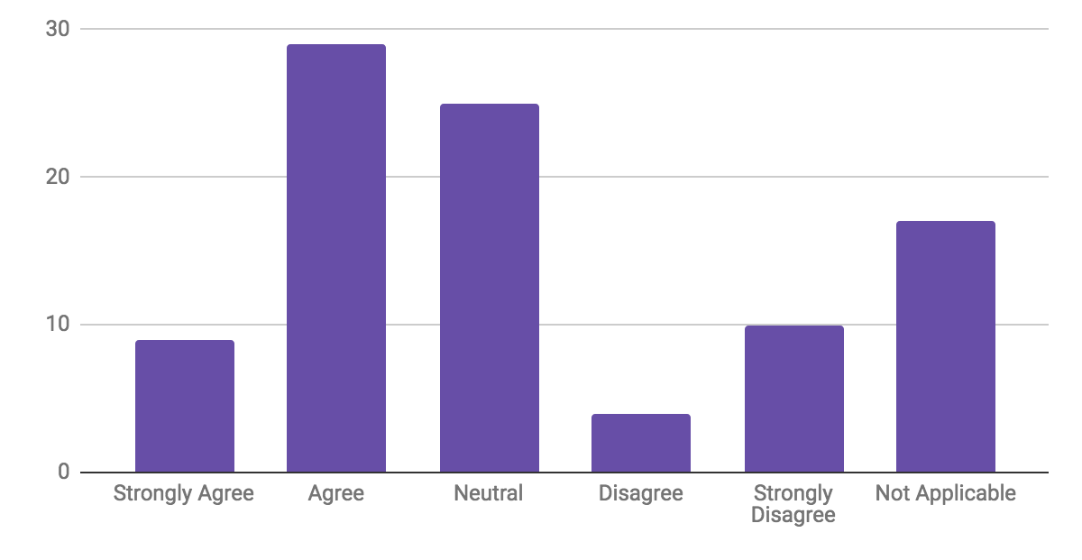

Graph 13. I feel like private transportation companies like Uber or Lyft in Washoe County value my thoughts and opinions. Ranked: Strongly Agree, Agree, Neutral, Disagree, Strongly Agree, Not Applicable. Primary response: Agree.

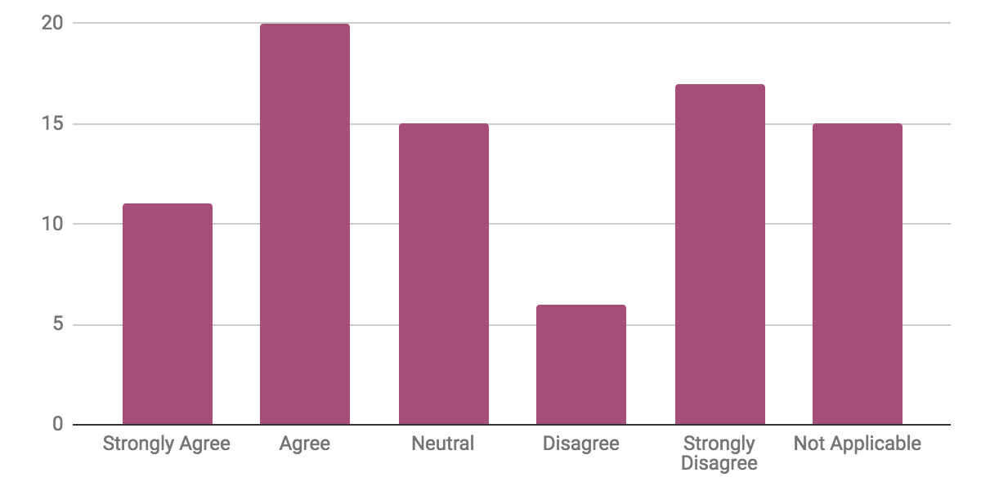

Graph 14. Which of the following are barriers for you to voice your opinions, thoughts, and ideas regarding transportation (e.g. sending emails, making phone calls, attending meetings)? Primary response: I do not feel my thoughts or opinions will be valued.
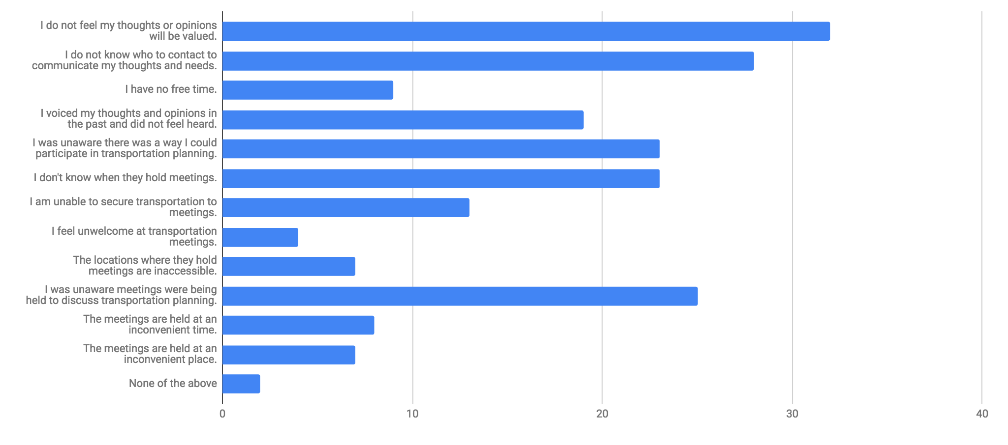

Graph 15. What days and times would work best for you to attend transportation planning meetings? Primary response: Tuesday afternoon.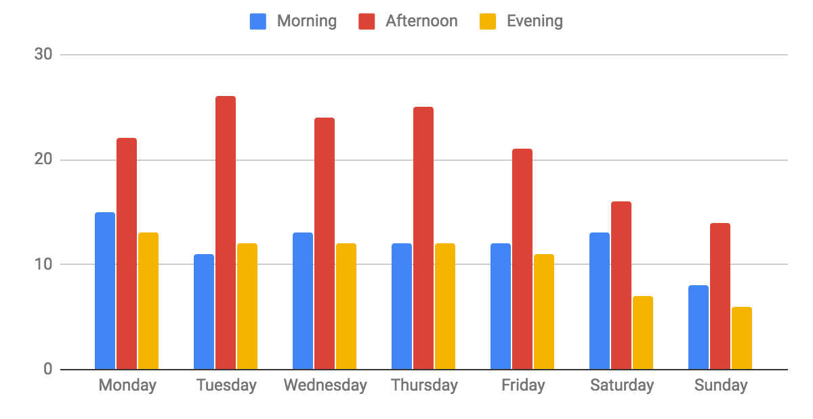

RECOMMENDATIONS

Themes, solutions, and prototype concepts

The N4 Transit Planning 4 All steering committee aggregated and analyzed both the qualitative and quantitative data gathered across the grant period in order to identify the central themes, or core issues, that are most important to community members. These themes were then used to develop and inform the design of potential solutions and prototype concepts.

The following themes were identified as most important to community members: advocacy, safety, streamlined technology, community involvement, reliable/resourceful sharing of information, accessibility, futility/responsiveness, and transit anxiety.

Advocacy

Beyond more extensive and representative voting power, including board membership, participants emphasized public gestures, self-advocacy, and so on, as ways of advocating for more inclusive transit planning.

Safety

Safety of public transit, and the improvement thereof, was suggested as a priority for future transit planning. With the increased safety of transportation, both stigma and trepidation related to public transportation might be reduced.

Streamlined Technology

For greater inclusion of older adults, people with disabilities, and their care partners, participants expressed that streamlining technology must be prioritized in transit planning.

Community Involvement

One of the top priorities identified by participants was the need to engage the community as a whole, from each individual to cross-organizational collaborations, in the push for greater transit planning inclusivity.

Reliable/Resourceful Sharing of Information

A major need of people with disabilities, older adults, and care partners was identified as the establishment of a system to share reliable and resourceful information. A major barrier to voicing ideas related to transit planning is “not knowing resources.” People do not feel as though they have the appropriate contacts, or the means to contact, appropriate sources with their transit concerns and ideas.

Accessibility

The accessibility of transportation and transit planning is a multi-faceted issue that was addressed extensively during this project. The relationship between accessibility and inclusivity was identified as crucially important.

Futility and Responsiveness

Feelings of futility were prevalent among participants, as many felt that their voices were not being heard. One individual with a disability explained, “They hear the words, but aren’t listening,” in reference to public transit agencies. Frustration was expressed at the lack of responsiveness towards attempts made to become more involved and was identified as a core component of what might be changed in the transit planning process to increase inclusivity.

Transit Anxiety

Participants stated that they often found it intimidating to speak out about transit, that the entire process of getting involved in transit planning, connecting to appropriate contacts in the field of transportation, and pursuing inclusion, was actually “daunting.”

Solutions

- Website that provides user-friendly, continuously updated information about:

  - Currently available transportation options and the ways to get in touch with or schedule these options
  - Opportunities to participate in transit-planning activities, as well as the ways to get to these activities
  - Methods of contacting relevant state, county, local, and nonprofit organizations about transit needs and concerns

  - Themes addressed: Streamlining technology, accessibility

- Sensitivity and competency training for transportation providers (both organizations and drivers) regarding best practices for interactions with older adults and people with disabilities

  - Theme addressed: Transit anxiety

- Expanded RTC-specific citizen advisory board comprised of older adults and people with disabilities that allows for the direct communication of needs, wants, and implementation strategies for desired changes for both RTC Ride (public bus) and RTC ACCESS (paratransit).

  - Priority issues:

    - Bus frequency
    - Cost of bus fare
    - Location of bus stops
    - Expansion of available bus routes
    - Expansion of ADA services outside normal transit zone
    - Expansion/cost reduction of Medicaid-funded medical rides
    - Transit accessibility issues
    - Bus stop accessibility
    - Sidewalk accessibility
    - Crosswalk accessibility

  - Themes addressed: Advocacy, futility/responsiveness, reliable/resourceful information sharing

- Enhanced accessibility of public meetings through more active communication with those being served regarding their needs and availability in terms of both when and where meetings are scheduled

  - Themes addressed: Advocacy, community involvement, reliable/resourceful information sharing

- Creation of educational materials that are easily accessible, widely distributed across multiple platforms, and designed for specific populations regarding transportation options and transit planning opportunities

  - Theme addressed: Reliable/resourceful information sharing

- Continuing work with Lyft, Uber, and other rideshare providers to increase the accessibility of their platforms and expand their services (including increasing the number of accessible vehicles available) to better accommodate people with disabilities and older adults

  - Theme addressed: Accessibility

- Continuing, active maintenance and growth of local transportation-related organizations and coalitions that advocate for transportation and transit planning inclusivity and accessibility

  - Themes addressed: Advocacy, community involvement

- Increased collaboration between relevant organizations to improve existing programs and create new programs

  - Themes addressed: Advocacy, community involvement

- Development of institutional training programs to help organizations improve semantics and reduce the psychological barriers related to communication

  - Theme addressed: Transit anxiety

Prototype Concepts

- Official “Transportation Swap Day” during which relevant state, county, regional, and organizational representatives use only public transportation

- Expanded shared ride options, to include regular, ongoing Lyft/Uber driver-rider pairings to allow for familiarity between rider and driver

- The training of staff at major transit stations to help people with disabilities and older adults

- The creation of travel training programs that include older adults and people with disabilities in leadership roles

  - N4 has initiated a program for a member with an intellectual disability who has extensive experience using public transit to facilitate bus travel training.

CONCLUSION

The N4 Transit Planning 4 All project has identified the most important barriers, most desired changes, and most impactful potential solutions for making transportation planning more inclusive and increasing viable transportation options in Washoe County. The project team has not only assessed and shared information about current successes and barriers in transportation systems, but also the current ways in which older adults, people with disabilities, and care partners participate in the transportation planning process.

TP4A was able to achieve increased participant satisfaction measures for the transportation planning process, enhanced community organization communication and collaboration, and a diversified and increased number of members participating across organizations. These efforts helped with improving the community’s rating on the Pathway to Inclusion from Level 3 (consults participants about programs) to a Level 5 (participants share decision-making).

Future Goals

N4 will continue to increase the community’s rating on the Pathway to Inclusion and maintain the participation of older adults, people with disabilities, and care partners in advisory and decision-making roles. The N4 team will continue to instigate the implementation of programs and designs developed during this project, including the expansion of N4 Connect, and will continue to work with partner organizations to collaborate, share information and programs, and encourage participation in multiple councils, coalitions, and initiatives. N4 TP4A catalyzed the beginning stages of the creation of systems in which community transportation planners are not creating solutions based on what they think older adults, people with disabilities, and care partners need, but rather on what the people they serve say they need.

Endnotes

Community Survey

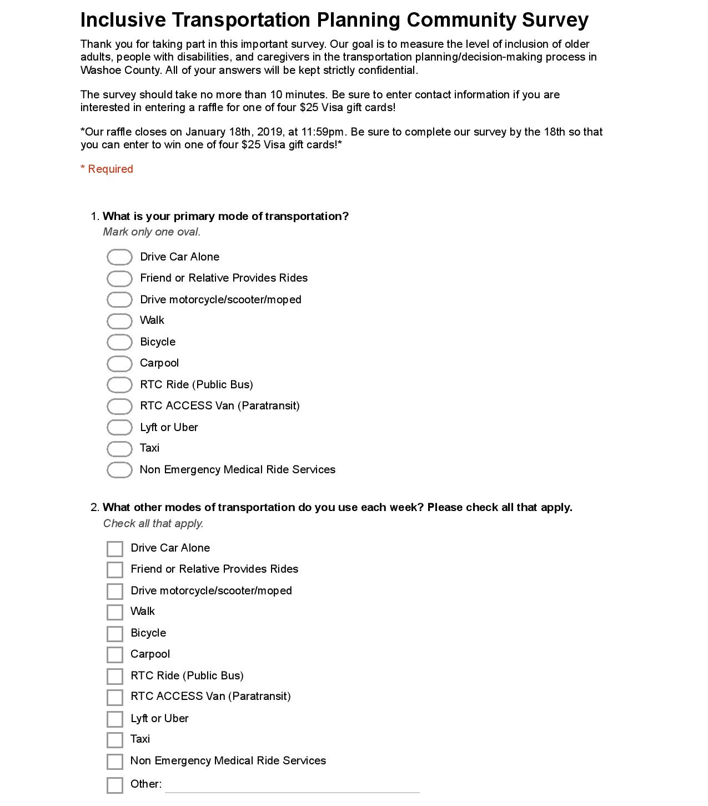
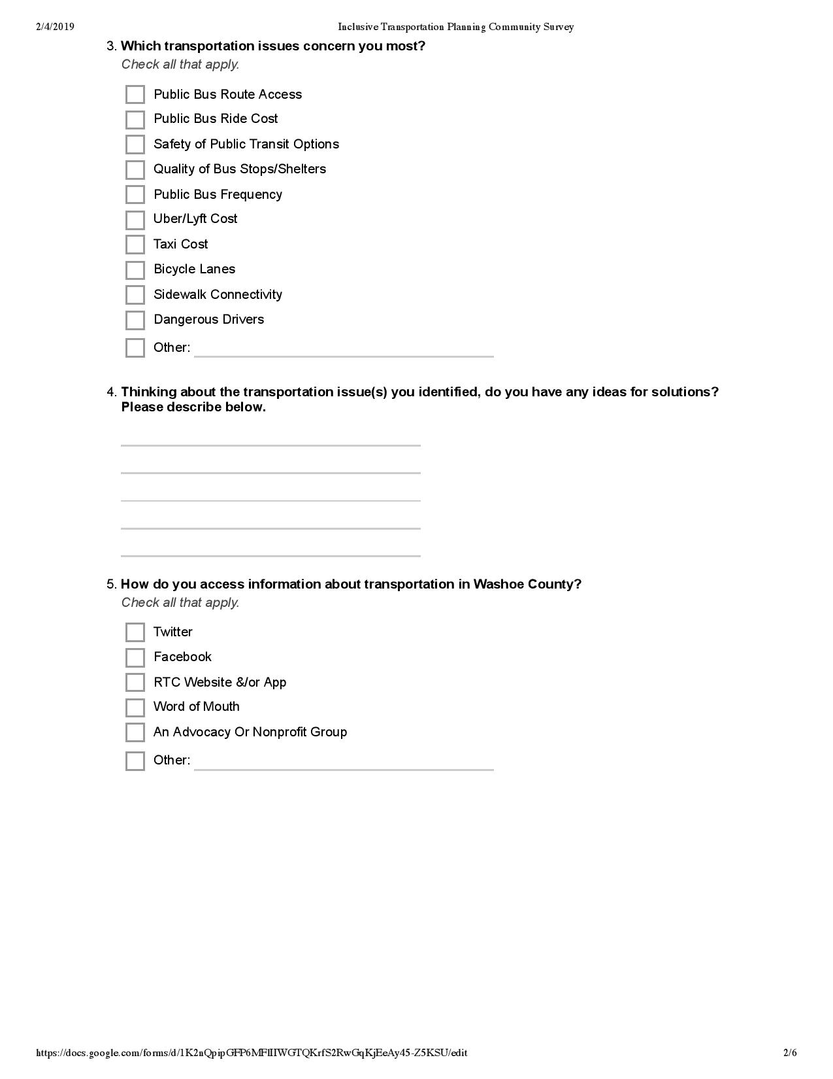
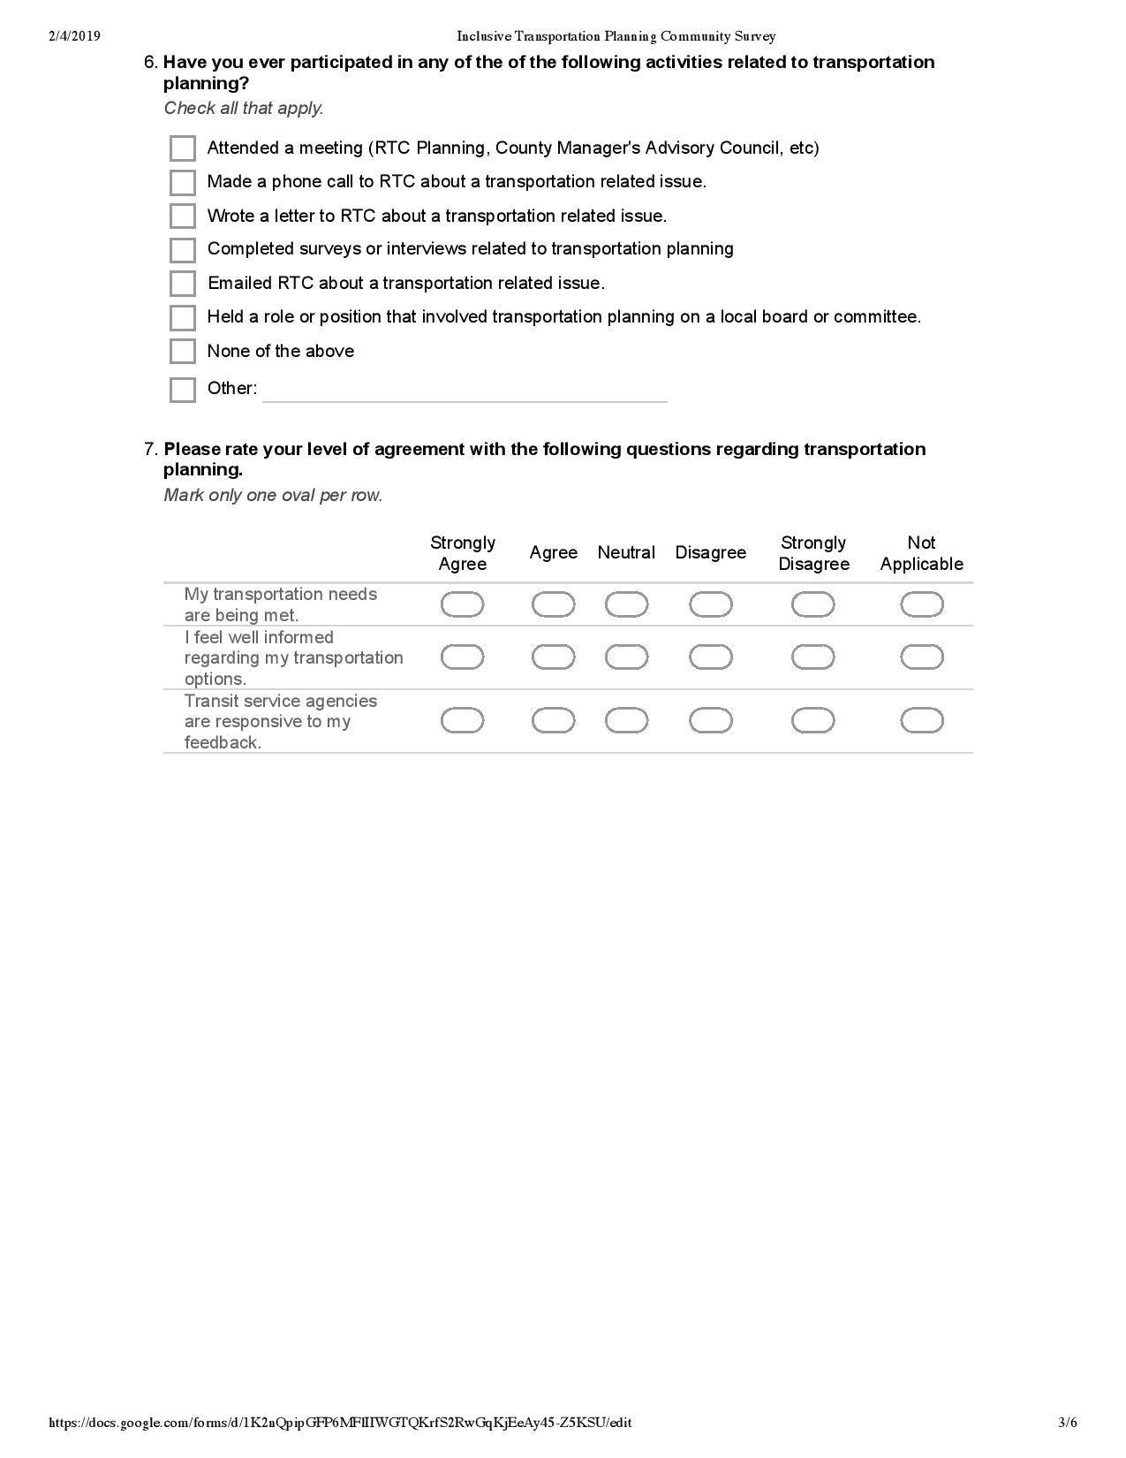

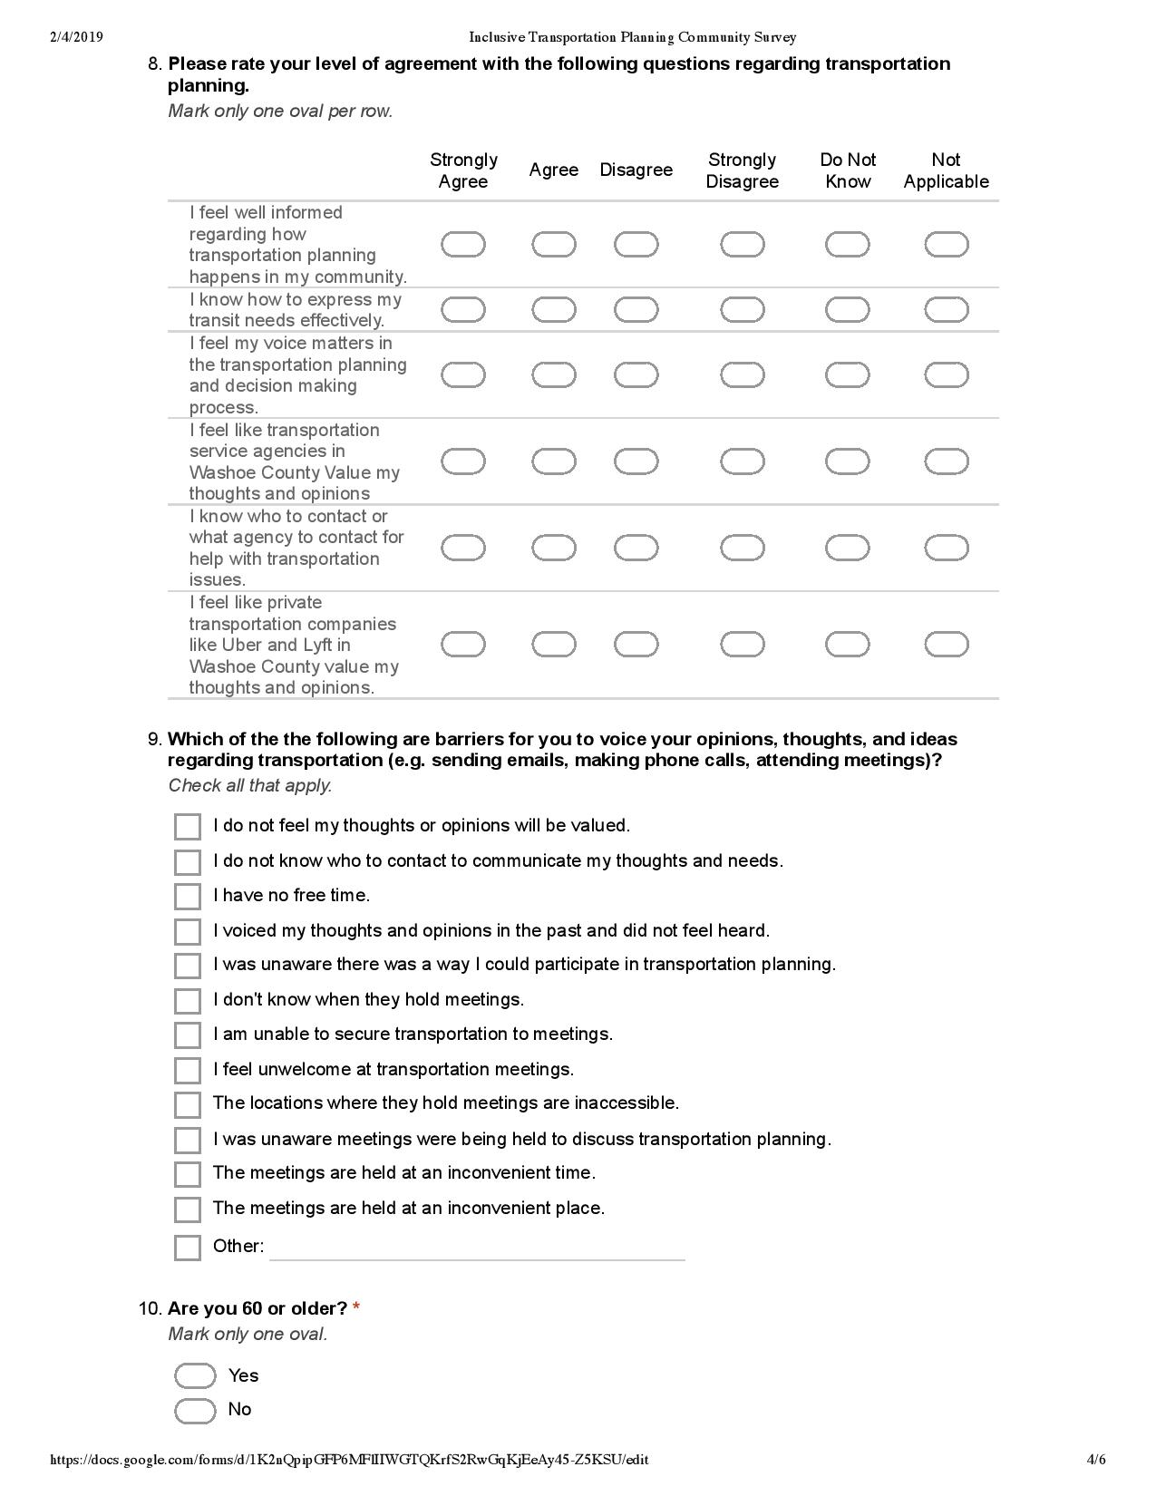

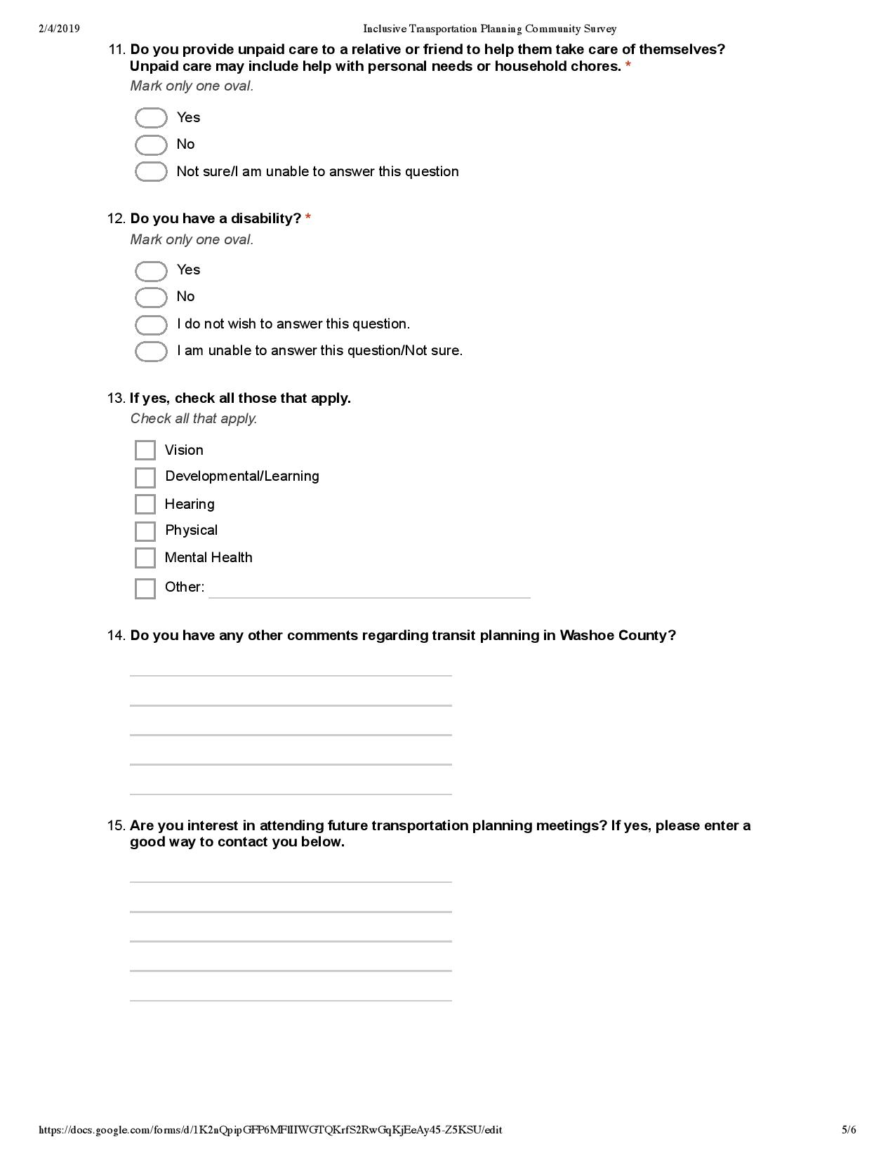

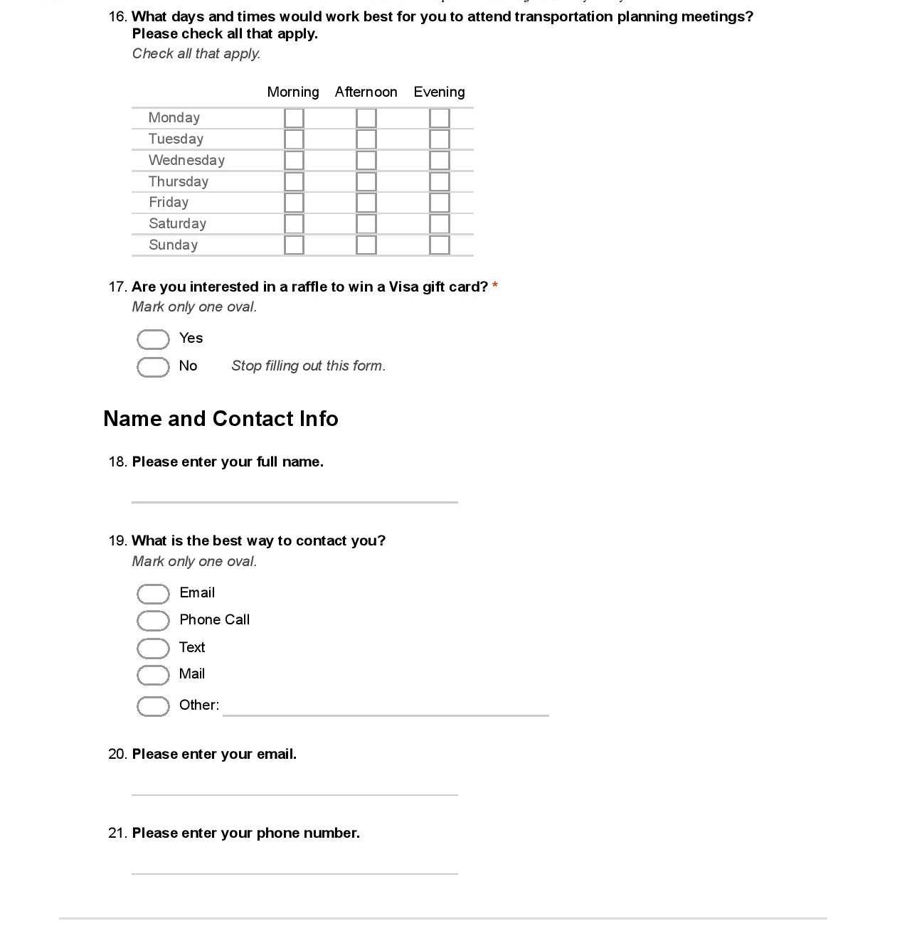

Endnotes

Participant and peer-to-peer interview questions

