Supported Decision Making

For Individuals with Disabilities
Supported Decision Making is a way to get the advice or help you need making decisions that matter to you in your life. It keeps you in control of your own choices with a little help from people or a person you trust!

Terms to Know
- Agreement = something that you say you are going to do
- Guardianship = a legal proceeding that can remove some or all of your rights and assign control to someone else.
- Provider = someone who is paid to help you complete certain tasks
- SDM = Supported Decision Making
- Supporter = someone you trust who looks out for you and gives you advice
- Witness = someone who watches you sign legal documents

What Can Your Supporter(s) Help With?
Nevada law allows you to use Supported Decision Making in any of these decisions if you say it is okay in your agreement:

- Your money
- Your health
- Where you live
- What you do for fun
- Your job or finding a job
- School
- Making appointments

What Can’t Your Supporter(s) Help With?
- Your supporter should NOT be making your decisions for you or meeting with people without your consent.
- Your supporter can’t help you with anything you’ve specifically said they shouldn’t help with.
- Your supporter can’t help with anything you haven’t given them permission to do.
For example: You are fine with your sister helping you make an appointment with your doctor and getting it on your calendar but you don’t want her to know what the doctor tells you when you go. That’s fine! If your agreement says, “My sister can help make appointments, but cannot have information about my medical care.” No one should be telling her what happened when you were there.

Important Information:
- You can change your supporter(s) at any time by making a new agreement and taking away the permission of the old agreement.
- No one can use the fact that you have a supporter(s) against you.

Who should you pick?
- Pick someone or a group of people you trust. When you trust someone, it means you know they care about your rights and freedom. It means that if you ask for advice, they will tell you the truth and not try to trick you into something you don’t want.
- Pick someone who is always there for you when you need them.
- Pick someone who knows what matters to you and respects your choices.
- Pick someone who doesn’t make you feel like you should be anybody but who you are.
For example: Your mom and dad have always been there for you and they would love to be your supporters but you don’t feel comfortable with them knowing details about your life all the time. You may be ready to be independent! You should not pick them as supporters if you are worried that they will make you feel bad for not listening to their advice. Your best friend might be a better choice for you. Or you can pick your parents for just those decisions you are okay with them knowing about.

Person Centered and Directed
Supported Decision Making is part of a bigger plan to put you in control of your decisions. You may need help getting or learning about the information you need to make a choice. The Supported Decision Making Agreement lets others know you don’t need someone else making your decisions, you may just need a little help.

The Agreement
Nevada law says your agreement must:

- Be in writing
- Name one or more supporter(s)
- Say what your supporter(s) can and can’t help you with
- Be signed by the individual and their named supporter(s)
- Have two witnesses
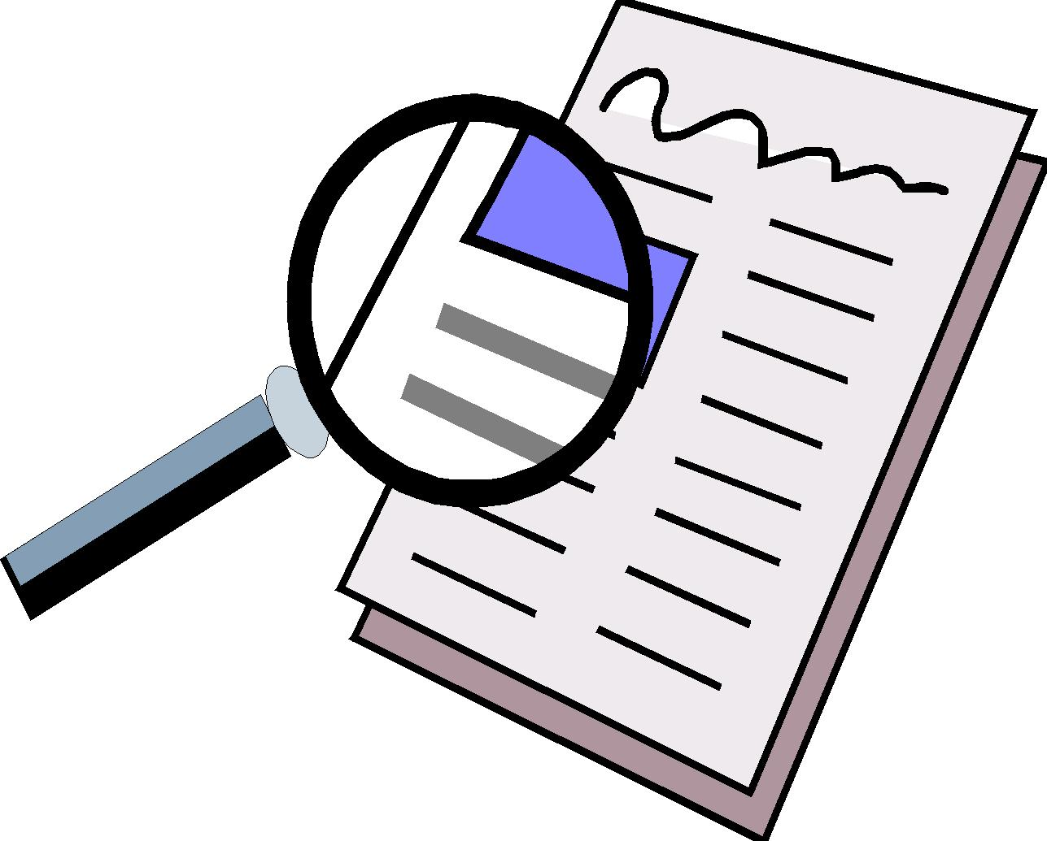
This Photo by Unknown Author is licensed under CC BY-SA-NC

What does this mean? Supported Decision Making agreements come in all shapes and sizes! There is no set legal form or template. If the document has the basics under Nevada Law (NRS 162A.XXX, AB480), you’re ready to go!

Where to Go for Help
- Nevada Governor’s Council on Developmental Disabilities | Nevadaddcouncil.org | 775-684-8619
- Aging and Disability Services Division | Adsd.nv.gov/ | 775-684-4210
- Nevada Disability Advocacy and Law Center | Ndalc.org | 800-992-5715
- Washoe Legal Services | washoelegalservices.org | 775-329-2727 has templates to review

*This flyer is not meant to replace legal advice. It is for informational purposes only. Adapted from Wisconsin Board for People with Developmental Disabilities. This publication is a partnership between the Nevada Governor’s Council on Developmental Disabilities and the Nevada Department of Health and Human Services Aging and Disability Services Division.

