Checking accessibility in a Microsoft word doc:
File, Check for Issues, Check Accessibility You’ll get something that looks like this…
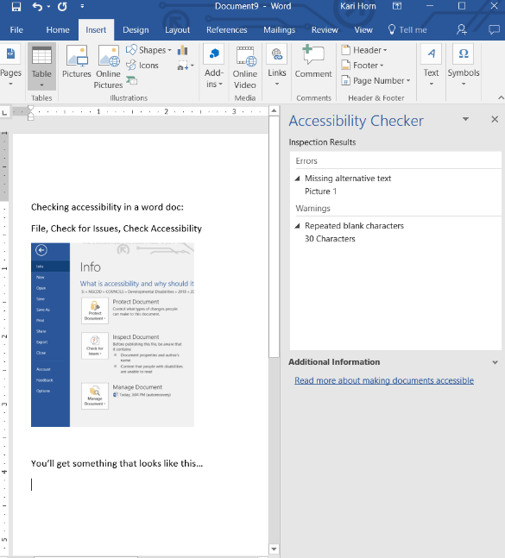
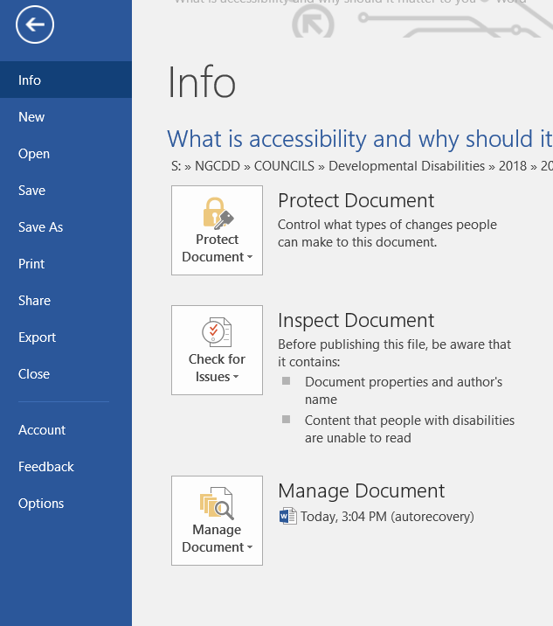
Checking for accessibility in Outlook:
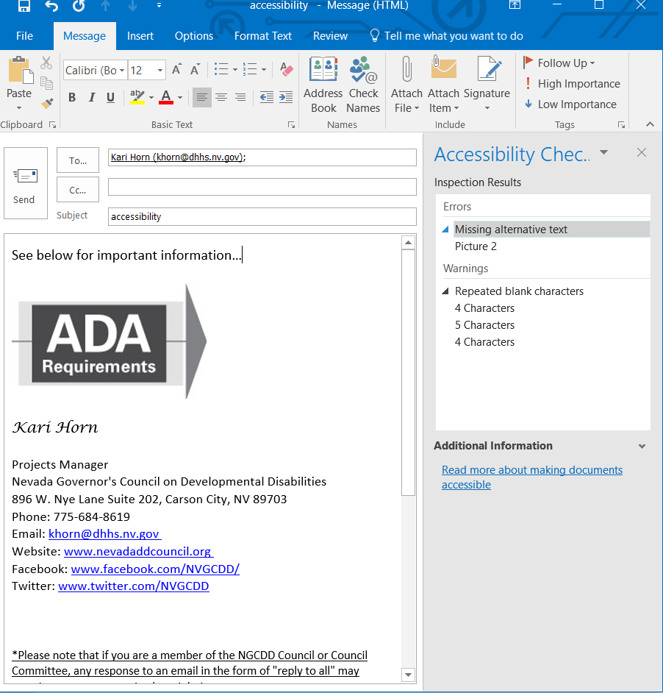
Review, Check Accessibility You’ll get something that looks like this…
