Nevada Governor’s Council on Developmental Disabilities

Making Microsoft Products Accessible:

People with visual impairments or reading disabilities often use tools like screen readers to read written content to them out loud. There are many ways to adapt documents to ensure equal access for all. These are just a few for users of Microsoft applications like Word, Excel, Power Point, etc.
For the Tips below, if you can’t find the options listed, you can always type accessibility in the Search or Help sections of your menu.

Use Accessible Templates:
- Click Open then New
- Type accessible templates in the search field. Accessible templates have a basic accessible format but you still need to check your content when editing and at the end for accessibility.
- Select templates and themes with solid backgrounds and high contrasting text color, sans serif fonts that are 14 points or larger.

Use the Accessibility Checker:
Many apps include an Accessibility Checker that finds problems and lists suggestions, or specific tips for making your content accessible.
- On the ribbon, select the Review tab.
- Select Check Accessibility.
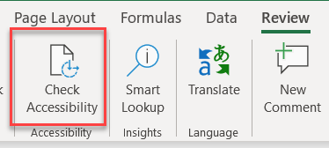
- Review your results and fix recommendations
- To address accessibility errors and warnings, select an issue to open the Recommended Actions list.
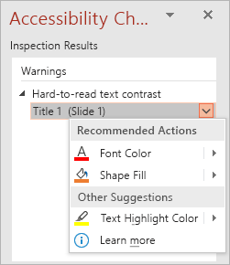
- To be notified of accessibility issues as your working, check the Keep accessibility checker running while I work check box. This adds the Accessibility button to your status bar and keeps track of accessibility issues as you go.

Don't see Accessibility Checker?
- Select File > Info.
- Select the Check for Issues button.
- Select Check for Issues.
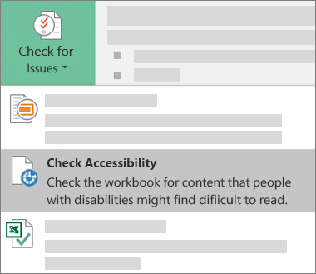
- To see information on why and how to fix an issue, under Inspection Results, select an issue.
- Results appear under Additional Information, and you’re directed to the inaccessible content in your file.

Use Read Aloud/Speak
Reads single words or blocks of text read aloud by selecting the text you want to hear and then clicking the Speak icon. Useful to verify reading order and content as it would be read by a screen reader.

Add the Speak button to the Quick Access Toolbar
- Click the Customize arrow on the Quick Access Toolbar.
- From the dropdown menu, select More Commands.
- On the Word Options screen >Customize the Quick Access Toolbar, locate the Choose Commands From box and scroll down to the Speak command.
- Select the Speak command, click the Add button in the middle of the screen, then click OK
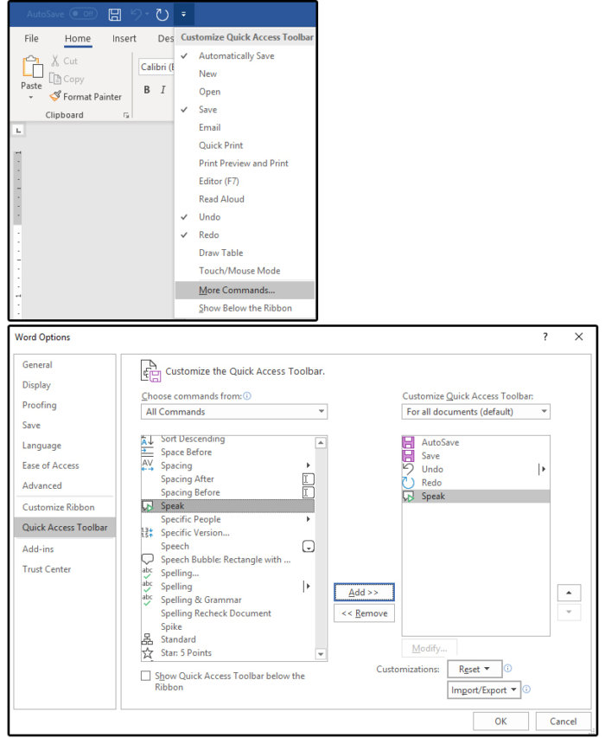

Use Alternative Text
  - Right-click the object and select Edit Alt Text or
  - Select the object. Select Format > Alt Text.
- In the Alt Text pane, type 1-2 sentences in the text box to describe the object and its context to someone who cannot see it. Consider what’s important. What are you trying to say with the image you’re using?
- Don’t use a file name, duplicate text, or URLs as alt text.

Pictures
- Use descriptive text that tells the story of the picture.
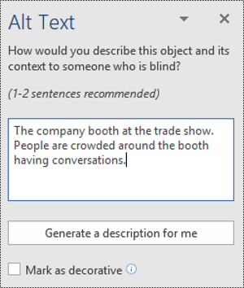

Diagrams, flow charts, and charts
- Use alt text to provide the information in the object. Describing a chart as ‘A bar chart showing sales over time’, for example, would not be useful. Try to convey the insight; for example, ‘A bar chart showing sales over time. In July, sales for brand A surpassed sales for brand B and kept increasing throughout the year.’
- Alt text should clearly describe the beginning point, progress, and conclusion of flow charts.
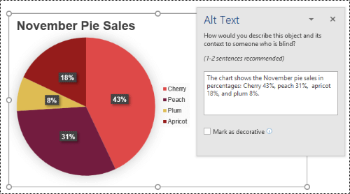

Videos
Videos that don't explain their content require alt text to describe the visual experience, even if the user hears music, background sounds, and speech. Alt text should describe the content and purpose of the video.

When not to use alt text?

Decorative visual objects
Decorative objects add visual interest but aren’t informative (for example, stylistic borders). People using screen readers will hear these are decorative so they know they aren’t missing any important information. To mark a visual as decorative, simply select the Mark as decorative check box when the Alt Text pane is open. The text entry field becomes grayed out.
Tip: If you export your document as a PDF, any visuals you have marked as decorative will be automatically tagged as artifacts, which means they will be ignored by screen readers when navigating through PDFs.
Tip: To spell check and correct a word you typed in the Alt Text pane, just right-click the word and select from the suggested alternatives.

Learn how to make content accessible in each of the following apps:
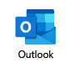 | Outlook for Windows  Outlook for Mac  Outlook for iOS  Outlook for Android  Outlook Web app | 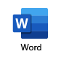 | Word for Windows  Word for Mac  Word for iOS  Word for Android  Word for Windows 10 app  Word for the web
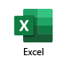 | Excel for Windows  Excel for Mac  Excel for iOS  Excel for Android  Excel for Windows 10 app  Excel Online | 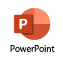 | PowerPoint for Windows  PowerPoint for Mac  PowerPoint for iOS  PowerPoint for Android  PowerPoint for Windows 10 app  PowerPoint for the web

Nevada Governor’s Council on Developmental Disabilities
Excerpts from Microsoft: https://support.office.com/
You can find more information on accessibility on our website: nevadaddcouncil.org/accessibility-101/

