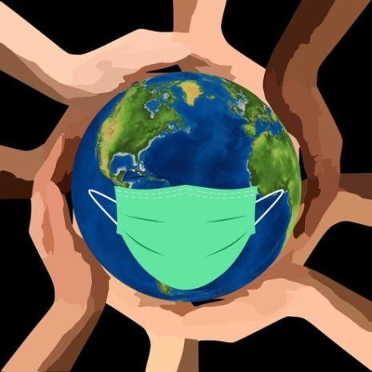

STATE COUNCILS ON DEVELOPMENTAL DISABILITIES
COVID-19 Report
Council Activities, Initiatives, and Impact

July 2020

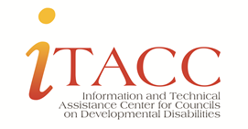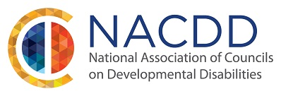

INTRODUCTION
Councils respond to the pandemic
As news of the COVID-19 pandemic grew and states began implementing containment measures in March 2020 and beyond, State Councils on Developmental Disabilities (Councils) across the country responded quickly. Their focus was, and continues to be, on ensuring people with intellectual and developmental disabilities (I/DD) and their families have access to critical information needed to stay safe and healthy, that healthcare and community service systems treat them fairly and equally, and that resources and supports are available.
With no time to waste, Councils pivoted to focus a lot of their time on this crisis. They leveraged a multitude of partnerships, staff and member expertise, and fiscal resources to implement a wide array of activities and strategies. This has included outreach, information and education, resources to help communities respond, demonstration projects to support capacity building and inform systems change, and policy advocacy.
As established in the DD Act, Councils were well-positioned to respond to the critical emerging issues described in this report.
Context: Why Council action was needed
While the Centers for Disease Control and Prevention (CDC) states that “disability alone may not be related to higher risk for getting COVID-19,” it also stipulates that people might be at increased risk if they 1) have limited mobility or cannot avoid coming into close contact with others, 2) have trouble understanding information or practicing preventive measures, or 3) are not able to communicate their symptoms.
While “stay at home orders” have been issued in the fight against COVID-19, they only work for people with disabilities if they can access the support they need at home. But even then, they are at risk if they depend on paid support because they cannot abide by social distancing recommendations. The direct support workforce challenges that pre-dated the pandemic, coupled with a shortage of personal protective equipment (PPE), and uncertainty over Medicaid funding as states face budget deficits have made it increasingly difficult for people with disabilities.
Other challenges were also identified by Councils, including problematic public policy issues noted in this report.
Purpose of this report
The purpose of this report is to describe the ways Councils responded to and are involved in pandemic-related activities. The report is intended to be useful to individual Councils with regard to the COVID-19 pandemic and to support preparation and response to future health crises and natural disasters. It is also intended to inform the development of additional resources, supports, and technical assistance to advance Council efforts, ultimately positively impacting the lives of individuals with ID/DD and their families.
Councils reported their COVID-19 activities through NACDD surveys in April and May 2020. This information formed the starting point for this report. Information was supplemented by a substantial amount of additional information gathered from Councils in June and July 2020. Overall, 47 Councils provided information on their pandemic response.
47
Councils
reported COVID-19 related activities

Strategies, initiatives, and other activities were collected and synthesized to offer insights on how Councils engaged and used resources and expertise to contribute to the pandemic responses in their states/territories. This is a snapshot in time. Councils continue to revise and expand their efforts.
Individual Council activities and initiatives are highlighted throughout as examples of the array of issues addressed and the outcomes or impact achieved. Links are provided when available. When multiple Councils had materials on the same topic, one is linked as an example. Data is also provided when available, as are some outcomes, but Councils will report the majority of this in their FY2020 Program Progress Report as intermediate and long-term outcomes are assessed.
SURVEY DATA
42/56 Councils reported pandemic-related activities on the April 2020 NACDD survey. Data on three key questions:

TABLE 1: In which ways have you worked with state agencies to address COVID -19 concerns?
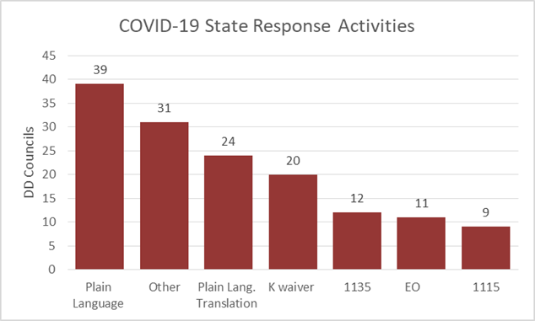
- 91% Created or disseminated "plain language" COVID-19 resources
- 56% Created or disseminated "plain language" COVID-19 resources in other languages
- 47% Advocated for/supported 1915(c) Waiver, Appendix K strategies
- 28% Engaged with their states/territories on their 1135 waiver and 21% on the 1115 waiver
- 26% Worked with their states/territories on an Executive Order
- 72% Reported other types of work with state agencies. These are discussed in the report.

TABLE 2: Which state offices did you work with on COVID-19 response?
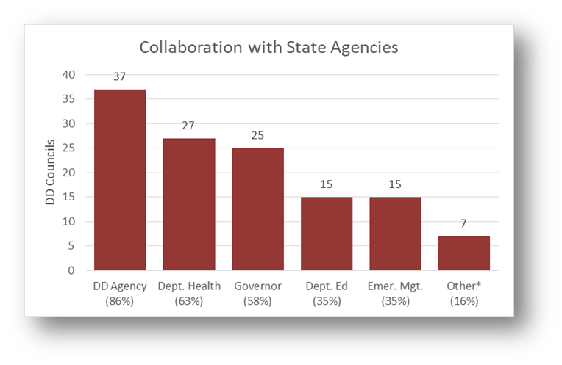
Other: state self-advocacy organization, Statewide Independent Living Council, family advocacy/support organizations, home health agencies, case management entities, unions, grantees, Mental Health Trust Authority, Ombudsman for MH-DD; American Civil Liberties Union, Census 2020 Complete Count Committee; Center for Health Equity, American Civil Liberties Union, and existing coalitions.

TABLE 3: Which other groups have you worked with concerning COVID-19 state response efforts?
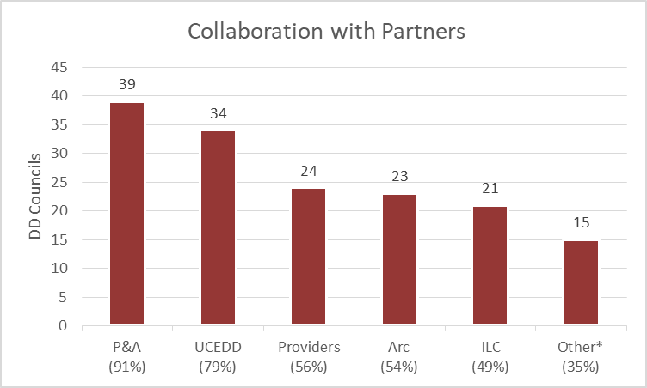
* Other: state self-advocacy organization, Statewide Independent Living Council, family advocacy/support organizations, home health agencies, case management entities, unions, grantees, Mental Health Trust Authority, Ombudsman for MH-DD; American Civil Liberties Union, Census 2020 Complete Count Committee; Center for Health Equity, American Civil Liberties Union, and existing coalitions.

COUNCILS RESPOND: ACTIVITIES, INITIATIVES & IMPACT

Collecting information about needs to inform action and affect outcomes
At least nine Councils reported engaging in some type of formal activity to gather information from people with I/DD and their families to better understand the impact of the pandemic. This took the form of statewide online surveys in different languages and virtual town halls/listening sessions.
These sometimes imparted information, but also always served as an avenue by which people with I/DD and their families could share issues, concerns, and ideas. Councils are using the information to inform and support ongoing advocacy to affect positive change in state policies and practices.
The focus of the surveys included identifying how people were impacted by the pandemic and what their needs are, assessing the adequacy of systems of support, learning whether personal protective equipment (PPE) was being shared with people with I/DD and their family caregivers, and addressing concerns about re-opening schools. For example:
- The TX Council developed a statewide survey for individuals with I/DD and their families to share how COVID-19 had impacted their access to health care, in-home supports, school and employment, as well as their ability to meet basic food and housing needs. The Council’s survey is the only source for this type of information about the I/DD population. The findings will be used to improve the state’s response to the pandemic and will inform local and state decision-makers about the strengths and gaps in support systems.

- The ME Council’s survey found that 26% of families with children with I/DD had not heard from their in-home support provider and/or case manager since COVID-19 began. The Council informed the DD agency and urged action. As a result, state guidance was issued making it clear that remote contact is critical, expected, and billable.
The WA Council convened virtual town halls with the state DD agency with nearly 800 people participating. Key questions and concerns were elevated to the DD agency’s leadership and the governor's office. Some of the results include:
- The DD agency developed an extensive 35 question FAQ document and has continued to hold webinars and produce documents since the town hall series ended. Attendees developed a deeper understanding of what the agency was doing and who to contact with questions or concerns.

- Based on the success of the virtual town halls, the DD agency decided to convert its previously cancelled Community Summit to an online format, bringing together self-advocates, families, and allies to talk about building inclusive communities.

- Many Councils gathered stories informally and some through formal solicitations. The stories gave Councils a deeper understanding of unmet needs. They shared the stories with government leaders, legislators, and the public to provide a window into people’s lives with the goal of ensuring their needs are addressed in state and federal-level pandemic responses. For example, the MN Council helped the local PBS station and the Star Tribune identify people to be interviewed for pandemic stories. The Council tapped a current Partners in Policymaking participant and graduates. Among other things, they talked about issues related to hospital visitation policies, the lack of educational services for students with IEPs, and isolation.
Engaging in outreach: information, education and resources
During an ongoing health crisis like COVID-19, factual, timely, and understandable information is critical – and for some people could be a matter of life and death. Working with their DD network partners, state agencies, and others, Councils served as a trusted source in their states/territories to get information quickly to people with I/DD, their families, and their support systems. They gathered and shared pandemic-related information and created new materials based on identified needs. This included: fact sheets, videos, virtual town halls and “chats,” webinars, lists of FAQs and tips, social media posts, dedicated sections on their websites, toolkits, direct mail, and email alerts with extensive resources. Councils sought answers from issue experts to ensure people with I/DD and their families receive accurate information.
Councils in at least 39 states/territories filled a crucial role by creating, funding, and /or distributing plain language information on a host of topics related to the pandemic. At least 22 Councils reported providing information in different languages. Their key audience was people with I/DD and their families. In some circumstances, the target was health professionals or the general public. Organizations providing supports and services, advocates, and others also benefited.

Topics included: COVID-19 basics, staying healthy (social distance, wash hands, wear masks), essential news updates, rights, guidance and materials for students with disabilities, formal and informal supports and services, unemployment insurance, federal pandemic legislation, waivers, economic impact payments and ABLE accounts, healthcare forms to help ensure medical staff provide effective care, voting, participating in virtual meetings, disaster readiness, self-advocacy, isolation, deaf and hard of hearing communication support, and other health and wellness resources like testing sites and food banks. Following are examples that illustrate the variety of efforts Councils engaged in.
Projects of National Significance take Action
Councils enlisted their Living Well projects in response to COVID. For example, the WI Council’s project developed a toolkit for people with disabilities, families, caregivers, and providers. It includes fillable forms, tips, links to information, and activities. A three-part live virtual walk-through of the content has been viewed by over 1400 people. 2800 people received the toolkit and over 600 have viewed it online to date.
Assistance and advocacy: Councils provided individual assistance to people with disabilities and family members who contacted them for help. For example, the MN Council recorded a 25% increase in inquiries. Issues they addressed included rights restrictions, hospital visitation policies, access to special education services, and workforce problems, among others.
Outreach: The IA Council developed a post card with plain language that was recently mailed to about 10,000 people with I/DD and their families. It offered a number for them to call if they wanted to talk to someone about COVID-19 and related stressors. The Council is currently monitoring the engagement rate as a result of this service.
Education: Educational issues were among the topics Councils addressed through virtual forums and individual inquiries. In addition, at least two Councils (AK and CA) developed early intervention and special education materials to ensure families of young children with I/DD know about their rights and available resources as local school systems respond to the pandemic.
ABLE: At least seven Councils have provided information and education through written materials, social media posts, and training to promote the use of ABLE accounts for people’s economic impact checks as a way to protect their eligibility for essential public benefits. Most of these Councils partnered with their state treasurer’s office.
Healthcare: The CA Council developed a strength-based, fillable health profile people can use to communicate with health care professionals. It can also be used with law enforcement. The governor’s office is translating it into multiple languages.
Emergency preparedness: The NV Council created an accessible emergency preparedness toolkit for individuals with disabilities that contains COVID resources, information about your rights during an emergency, and a form to provide information about your medical history and needed accommodations to healthcare or emergency personnel.
Self-determination: The OR Council contracted with a self-advocate to launch a series of video podcasts that use Charting the LifeCourse principles to explore how people can still practice self-determination during the pandemic.
The HI Council got creative by sponsoring the Hawaii Youth Advocacy Film Contest with the Self Advocacy Advisory Council, HawaiiKidsCan, and Hawaii Women In Filmmaking. Student filmmakers produced one-minute public service announcements to inform people about the state’s new vote by mail initiative and how it will affect voters with disabilities.
Supported decision-making: Knowing that COVID-19 is not going to be a short-lived health crisis, the MO Council produced a booklet focused on supported decision-making during pandemics. It covers how supported decision making can help people be healthy and safe, connected and supported, and ready for changes in their lives.
Voting: At least four Councils reported educational activities specifically about voting during the pandemic. The WI Council and the Disability Vote Coalition hosted 4 webinars for more than 150 people on voting and COVID-19 to address fast-changing rules around the primary election. They helped voters understand their rights and how to vote absentee or stay safe if voting in person.
Regular and timely information via social media: The OK Council uses its social media and website to send weekday messages under themed banners like #MindfulMonday (mental health, managing stress) and #WorkOutWednesday (physical activity during social distancing and isolation). Likewise, the TN Council launched a weekly series on social media called “COVID Q&A” where they publish in plain language a summary of questions they received and answers they gathered related to COVID-19 policy changes.
Live virtual forums that are responsive to emerging needs: The Georgia Council, in partnership with the DD network and other organizations, hosts a weekly community call to address issues and concerns related to COVID-19. The goal is to provide clear guidance and resources. ASL/CART services are provided and the sessions are recorded and available the following the day. Similarly, The NC and NJ Councils worked with state agencies to hold regular weekly calls/virtual town halls with families and individuals with I/DD. The MI Council pulled together a statewide group of disability organizations to host weekly webinars that broadcast on Facebook in order to reach people who can only access the internet with a cell phone.
The KS Council started “KCDD Coffee House,” weekly zoom calls to help people connect, support one another, and share needs and ideas. About 300 people participated in the first 10 weeks. The Council reports that “engaging in everyday conversations on a regular basis sheds a whole new light on issues, both large and small, that impact families and self-advocates.” One participant commented on how being able to connect with other people virtually helped him keep from going to a “dark place” mentally.
Providing information and resources to help communities respond
At least three Councils developed or adapted resources for health care professionals and the public. Other Councils used and/or modified these materials.
- The MO Council worked in collaboration with the UCEDD to complete Tips for First Responders. It is available as a mobile-device tool that provides first responders quick and helpful tips to equip them to successfully support people with disabilities during emergencies.

- In response to concerns that coronavirus testing sites were not prepared to communicate with people with disabilities, the TX Council worked with the governor’s office to develop a short guide for health care workers on Successful Communication with individuals with DD. It is designed for health care staff at drive through testing sites and medical facilities. The guide is also being used by other states. For example, the VA Council had 5,000 copies printed and laminated and coordinated distribution to testing sites statewide with the Department of Emergency Management.

- In collaboration with their state department of health, the AK Council created and distributed a flyer about exceptions to mask requirements related to disability.
Getting critical Personal Protective Equipment and other supplies where they are needed

As the coronavirus spread, states quickly experienced shortages of essential personal protective equipment (PPE). Typically, the equipment that was available was reserved for healthcare workers and first responders. As described later, Councils advocated with their state systems to help providers and direct support professionals (DSPs) access PPE. In addition, at least six Councils worked directly to get PPE into the hands of people with I/DD, their families, and support providers. By identifying supply chains and utilizing established statewide networks, they reached thousands of people at risk. Some highlights:
Unmet Needs Met – Networks Engaged
The MA Council knew that more needed to be done to protect medically fragile children with disabilities from the coronavirus. Their families and the home care nurses that provide them services needed PPE. The Council worked with a local TV news station to draw attention to these needs. After the story aired a group of Harvard students that had raised money for and purchased masks donated thousands to the Council. The Council then coordinated distribution of masks and gloves through Family to Family Resource Centers, DD agencies, food resource centers, homeless shelters, and direct mail. As of the end of May, 4100 masks and 1000 pairs of gloves had reached families. One family’s response was, “Thank you – you’ve saved my daughter’s life.”

- Latinx needs met - Relationships matter: Using insight gained from participation in cultural competence training funded by OIDD, the ID Council has worked over the past four years to develop relationships within the Latinx community. The trust and relationships the Council established have helped the disability community quickly respond to the needs of farmworkers, many of whom have family members with disabilities. The Council approached the local independent living center, which agreed to have volunteers sew masks for farmworkers. Within a week, 430 masks were produced and the Council coordinated distribution.
Leveraging Contributions from the Community
The MD Council partnered with the statewide DD Coalition on the We've Got You Covered campaign, which solicited donations of masks and money to purchase PPE for people with I/DD, direct support professionals, and family caregivers . 9358 pieces of PPE were donated or purchased: 3152 cloth masks, 6020 KN95 and surgical masks, and 186 face shields. These have been distributed across 15 counties and Baltimore City.

- Helping students and teachers: The MO Council linked a CIL with their emergency management agency to fulfill a request for PPE and connected a school district in need of PPE for 20,000 students receiving special education services and 6,000 staff with their local public health agency emergency planner and provided protocol for requesting PPE through the Strategic National Stockpile.

- Supporting people at home: The VA Council acted when they learned that some people receiving consumer-directed services lacked PPE for themselves and/or their attendants. The Council provided leadership and partnered with the Arc Virginia and Centers for Independent Living to distribute 2,000 face masks to people who live on their own or with family and have supports coming into their home.

- Self-advocates supported to act: The HI Council supports self-advocates as trainers for Feeling Safe Being Safe, which typically focuses on hurricane season. This year COVID-19 was incorporated. The trainers sent training materials to over 900 certified homes for individuals with disabilities, 65 agencies that provide services for people with disabilities, and 1,200 homes of individuals with disabilities and their families.
Leading the Way - Achieving Results
The CA Council leveraged its relationship with the governor’s office and the Office of Emergency Services to acquire and distribute 33 million pieces of PPE to people with disabilities, their families, caregivers, and service providers. Utilizing a volunteer network of over 300 community partners, the Council’s 12 regional offices are ensuring that individuals and organizations receive the paper and cloth masks, masks with clear plastic panels to read lips, face shields, hand sanitizer, and gloves they need to stay safe and healthy. The value of this PPE is $25 million and this massive, coordinated effort continues.

Adapting existing projects to continue work on state plan objectives
Council flexibility is essential to meeting emerging needs and this proved true in how they worked with grantees in response to COVID-19. All Councils that support in-person education, training, and skill building programs and events responded by helping grantees switch to virtual formats when possible. This helped grantees continue progress toward defined advocacy, capacity building, and systems change outcomes.
Self-advocacy training, Partners in Policymaking, topical trainings, conferences, and mentoring moved online. This provides a unique opportunity for Councils to learn what works and what doesn’t, how to fully support people with I/DD to participate, and whether certain topics or events are as successful as their traditional in-person formats. This will be useful to Councils not only as the pandemic continues, but afterwards as well. If good outcomes can be achieved, Councils may choose at least in some circumstances to incorporate more virtual education and training as a way to reduce costs, utilize a more diverse group of issue experts throughout the state, reach more people, and draw from underserved areas. These examples illustrate creative approaches on many topics:
Supporting underserved communities: A project supported by the WI Council reported that Ho Chunk tribal families who have a member with a disability were experiencing high levels of stress and isolation as they struggled with unemployment, lack of resources, and keeping their children connected to school. Their challenges were complicated by the fact that they were not using many supports they qualify for because they do not find them culturally responsive. Many of these tribal families were already experiencing poverty and food/housing insecurity prior to COVID-19. The Council responded by funding a Family Navigator position to build trust and provide intensive case management during COVID-19. A similar position was funded to support Hispanic families.
Building Capacity
A TX Council advanced training program for DD professionals has supported participants to conduct activities that improve their agency capacity to support individuals with I/DD during stay at home orders and social distancing. And a reading program in Dallas originally held in person is developing parent resources to build home-based learning opportunities for people with I/DD.
Using Skills for COVID-19 advocacy: The TX Council’s leadership and advocacy training projects continue to stay connected online. They have shifted their focus to speaking out about local and regional policy issues related to COVID-19 such as health care, unemployment, and education.
Empowering People
The MO Council was only able to hold two face-to-face Partners in Policymaking sessions prior to suspension of the program. Even so, after only two sessions 30% of participants reported educating their policymakers on issues important to them.
Figuring out new ways to make an impact: One SC Council grantee was focused on healthy living in group homes, including meal options, exercise, and diabetes management classes. They did not want to lose the momentum and the healthy habits that had been established so the Council helped them develop a plan that redirected funding to technology and remote classes with support provided. They enhanced meal planning and shifted to having food delivered.
Increasing access through technology: Before the pandemic, the UT Council had awarded a small grant to the Statewide Independent Living Council to support young adults to attend advocacy and leadership training. When COVID-19 put an end to these trainings, the Council modified the activities to instead allow the SILC to purchase technology for emerging advocates to participate virtually. The Council is helping develop a technical assistance plan to ensure people learn how to utilize the technology.
Expanding creative approaches: The MA Council’s Self-Advocacy Leadership Training Series, typically led by Self- Advocate Peer trainers on college campuses, was quickly reworked to be taught virtually to transition-aged youth with disabilities across the state. Trainings were taught via zoom, utilized breakout rooms, and provided interactive opportunities for the students to learn. Other disability organizations have also used the Council’s online model to reach young adults.
Adapting to New Realities through Innovation
Participants in the MS Council’s Designing VR Employment Training initiative are practicing virtual job interviews using a social chat option. Efforts are underway to provide virtual learning experiences where each participant has their own job employment training option.

Investing in new COVID-related projects and initiatives

In addition to modifying or expanding established projects, at least 20 Councils reported investing in new initiatives in response to the pandemic. Investments ranged from $15,000 to $385,000, each of which supported multiple individual projects. Demand was high and typically exceeded the available resources. While state/territory and Council policies and procedures for awarding funding can be onerous and time consuming, many Councils reported the ability to act quickly while maintaining accountability.
As the following examples illustrate, Councils designed initiatives to directly impact people with I/DD and their families while assessing the outcomes. Demonstration projects inform systems change. They plan to use lessons learned to not only have an impact during the current pandemic, but beyond. This is a unique, albeit unwelcomed, opportunity to test new approaches given the length of this health crisis.
Technology:
- Based on data that suggested that adults with I/DD who receive waiver services are lagging significantly behind other citizens in terms of access to technology, the ME Council funded the Access to Technology for Mainers with DD project. This pilot project is focused on increasing people’s connection to family and friends, services, telehealth, and opportunities for self-advocacy through direct access to an iPad – 148 were provided statewide. The Council is partnering with the UCEDD to provide technical support to all recipients. ($50,000)
Outcomes of the project will be evaluated to assess the impact on community inclusion.

- The NE Council started an initiative focused on demonstrating the effective use of technology, including training and outreach, to address loneliness. They gave special consideration to applicants who addressed an identified underserved group: Hispanics, refugees, rural residents, or elderly caregivers. ($45,000)

- The MO Council created a COVID-19 Scholarship Fund to provide one-time funding for technology. Allowable activities included: activities that target stress and anxiety reduction due to social distancing (e.g., facilitation of peer support groups), adapting to COVID-19 (e.g., managing work and school at home, staying connected with family and friends), meaningful virtual engagement during social distancing, and other items to support people’s access to health care during the pandemic (e.g., teaching a class on telehealth, developing resources to explain COVID-19 and how to stay healthy). The state vocational rehabilitation agency will cover technology requests related to employment so the Council can focus on people whose needs cannot be met elsewhere. The information gained will help the Council understand the scope of need that exists and plan accordingly. ($100,000)

People + Technology = New Possibilities
The CO Council formed a partnership with AbleLink Smart Living Technologies and the Coleman Institute to provide 500 adults with I/DD, at no cost, a tool designed to make information and technology more accessible. The tool provides accessible information about the coronavirus and how to stay well, empowers people with new ways to stay in touch with others, and encourages people to connect with the community. The goal is to help people discover what is possible when information and technology are accessible.
- The MD Council invested in a time-limited demonstration project focused on students with I/DD. The Assistive Technology Supports for Students project will identify strategies to support the assistive technology needs of students with I/DD and their families, including the purchase of assistive technology devices, to help students learn and succeed at home. ($81,000)

- The KS Council has allocated funding for a pilot project to get technology to people with disabilities and family members so they stay connected, attend virtual meetings and gatherings, learn, socialize, and remain active. The project will look at who needs technology, what support and training they need to access it, and related barriers like the cost of internet service. ($25,000)
Gaps in Services:
Over 156,000 people with I/DD will benefit from Council demonstration projects.
At least nine Councils have invested in COVID-relief demonstration projects (not noted elsewhere) that address gaps in services for people with I/DD and their families due to the pandemic. These time-limited small grants and scholarships have focused on building and maintaining community capacity to support the short-term and long-term needs of individuals with I/DD. They are also informing systems change efforts for future disaster preparedness and emergency response. Some Councils allowed people with I/DD and families to apply directly while others only funded organizations that support people. Focus has included things like improving access to telehealth and telework, combating social isolation, supporting learning, facilitating access to services, supporting leadership development, improving access to and long-term proficiency with technology, improving wellness, and enhancing emergency preparedness. As a result, people with I/DD are expected to be less isolated, more engaged, and better supported. In total, these Councils invested $892,500 and estimate that over 156,000 people with I/DD will benefit.
Impact
"I cannot remember receiving a grant of any size that was more exciting for all of us than the Iowa DD Council COVID-19 Relief Fund award! It came when we needed it most. This grant allowed us to purchase items that have made a real difference in the quality of life for the people we serve!" The grant helped reduce the anxiety and social isolation individuals with I/DD were experiencing as a result of the pandemic.
COVID Relief Funds
Parents of Extraordinary Children (PExC) is a volunteer led organization serving people with I/DD and their families in Chicago that received a COVID Relief grant from the IL Council. With a focus on supporting families in a low income, majority Hispanic community, PExC is providing wellness checks, Zoom group support sessions, information and resources in Spanish, access to technology, and supports for those experiencing stress and isolation due to remote learning and social distancing. The grant will make it possible for PExC to serve approximately 104 people with I/DD and their families who are typically underserved.

Other Issues:

- Addressing the workforce crisis: Nebraska has the highest turnover rate of DSPs (68.8%) in the country. To address this, the NE Council is funding a public awareness project to recognize the critical role of DSPs in the lives of people with I/DD during and after the pandemic. The plan is to help educators, employers, policymakers, and citizens understand the importance of DSPs, inspire them to support advocacy efforts for livable wages, and initiate action on at the local, state, and federal levels to recognize DSP’s as an essential workforce for the disability community. Stories and videos will also serve as a tool for DSP recruitment and retention. ($30,000)

- Increasing connections: The RI Council and state Arc are creating an online I/DD community of individuals, families, and caregivers to ensure continued engagement during and long after this period of social distancing. The initiative is called Circles of Connections: Real People, Real Support, Right When You Need It. It recognizes that isolation for individuals with disabilities and their families was a problem before the pandemic and its effects will linger long after the pandemic has ended. This initiative will provide connections and support by trained group leaders to foster friendships, respond to requests for assistance, inform individuals and families about resources, and provide self-care training. When pandemic restrictions are lifted, activities will shift to further the social connections that were forged online.
National Core Indicators 2017-18 Data
43% of those surveyed reported feeling lonely sometimes or often.
https://tinyurl.com/y2pg5zjr

- Supporting students: The SC Council funded small grants (under $5000 each) directly related to schools and day programs closing, with a focus on keeping people connected and better prepared going forward. One project established a virtual summer camp to help transition aged students be better prepared as they return to school in the fall because students with IEPs were not getting what they needed.
Improving Emergency Preparedness
One NE Council initiative is based on their assessment that individuals with I/DD and their families are underserved in the emergency preparedness planning process. The Council invested in a project to develop innovative approaches and creative solutions for developing emergency plans specific to individual’s needs and abilities. The project will demonstrate how collaborating with local emergency planning agencies and connecting with local disability organizations will ensure inclusion in the emergency preparedness planning process.
Expected outcomes include: Emergency shelters are accessible and adequately prepared to support individuals with disabilities, emergency information and materials are available in alternative formats and languages and easily accessible, emergency planning is included in service coordination plans, and coordination and communication between the state and local health departments is improved.
The outcome will improve the response to different types of emergencies, including health crises, terror attacks, and natural events like earthquakes, tornados, and blizzards. ($30,000)
- Reducing barriers and driving future change: The NY Council is starting a new initiative that will support immediate and long-term projects in response to the pandemic’s impact. Their emphasis is on supports for people with I/DD to ensure they are informed and not isolated, supports for families providing care at home for their family member with a disability, and ways to bolster the service delivery and other systems to better respond to current needs and shortfalls as well as be prepared for future crises. ($150,000)

- Leveraging Funds: The AZ Council teamed up with the AZ Community Foundation and the state Arc to offer small grants in the amount of $500-$2,500 for organizations that provide direct services to people with I/DD to decrease social isolation and anxiety. The Council committed $50,000 and the foundation $20,000. Funds are being used to support a variety of engagement activities.

- Fighting budget cuts: The MD Council provided funding for a public awareness campaign to raise awareness of the needs of people with I/DD, families, and service providers during the pandemic. The campaign will help in the fight against budget cuts at the state and local level that could jeopardize community supports and services for people with I/DD. ($10,000)
Evaluating Best Practices & Outcomes
The WI Council is supporting 15 agencies to evaluate the essential elements and outcomes of providing high quality virtual HCBS day services and self-advocacy/peer group services to people with I/DD. The findings will be used to formulate policy recommendations, as well as create guidance for service providers.

Advocating for effective policies and practices
Councils responded to the pandemic by advocating for effective communication from state and local government; adoption or modification of policies; equitable access to healthcare, education, and community supports; and enforcement of people’s rights. The following activities were reported by 33 Councils conducted in close collaboration with allied organizations and stakeholders in their states. Through this range of activities, Councils helped shape state and local responses to the pandemic while advocating for the unique issues facing people with I/DD.
Healthcare Access:
A recent Harvard Medical School national survey of doctors’ attitudes toward people with disabilities found that “the vast majority of doctors view quality of life for people with disabilities as less than that for people without disability… That’s an implicit bias, or maybe it’s an explicit bias, that is inevitably going to affect how they approach a person with a disability.”
https://tinyurl.com/ybvgw6q6

As TIME reported, “even in normal times, people with disabilities and chronic illnesses confront biases in medical care, face waiting lists to get support in their own homes instead of at nursing homes, and struggle to access government benefits. But amid a global pandemic, those challenges are heightened.” Councils responded as follows:
- At least 21 Councils found it necessary to ensure that health care providers comply with federal law regarding non-discrimination in access to medical care. This came as concerns grew about heath care and equipment shortages leading to prioritization of care. They advocated for their state leadership to issue formal directives that made it clear that "persons with disabilities should not be denied medical care on the basis of stereotypes, assessments of quality of life, or judgments about a person's relative 'worth' based on the presence or absence of disabilities.” Established relationships and coordinated advocacy helped Councils achieve this outcome. For example, as a member of the Delaware Office of Preparedness Medical Ethics Advisory Group, the DE Council was well placed to convince the group to change their Crisis Standards of Care to clearly state that medical rationing for people with disabilities is not acceptable.
- As hospitals stopped allowing visitors, numerous Councils worked to ensure they still provide reasonable accommodations to people with disabilities; that is, allowing them to have access to support persons or their parents/legal guardians while hospitalized. Councils convinced states to send formal notification to hospitals and informed people with I/DD and their families of this right. The OR Council and partners were successful in getting the state legislature to pass a statutory mandate. Councils also developed informational materials on this topic, such as the TN Council’s Hospital Visitor Tip Sheet for Individuals with Disabilities Who Need a Support Person, develop with their DD Act sister agencies.
Enforcement of Rights: Hospital Visitation
The MN Council illustrated the impact of this work from the perspective of one family that was denied this accommodation: “… just thinking of the families that will not have to go through what we did makes us so happy and means the world. This will help to move things forward everywhere.” – Sibling

- Based on their survey findings, the TN Council worked with state leaders to launch a comprehensive COVID-19 testing strategy for people with I/DD.
Home and Community Supports and Services:
The NJ Council advocated for an online portal to match staffing resources with people with disabilities needing support. As a result, the NJ Collaborative for Citizen Directed Supports launched a website to begin this effort.

Supports launched a website to begin this effort.
- Councils advocated for direct support professionals (DSPs) to be classified as essential employees and for them to be among those deemed a priority for PPE. The VA Council advocated for a pipeline for service providers to obtain PPE. The state responded by contracting with a company to help assess the supply chain and determine the extent of the need.

- The HI Council learned that people did not want to attend their day programs but were told they had to go if they were open. Seeing no action on the part of the DD agency to ensure people’s safety, the Council worked with members of the Self Advocacy Advisory Council on their advocacy skills and they then took action to get the vast majority of day program providers to close.

- The RI Council argued for the state to fund the extra costs providers incur when staff has to work overtime due to staff shortages.
- A MN Council representative serves on the state Olmstead Subcabinet, monitoring progress of the state’s Olmstead plan. This is providing an opportunity to positively influence any changes that may be considered in response to the pandemic.
Informing state and federal legislators about the needs of people with I/DD: SEEING RESULTS
As the state legislature met about budget cuts, the UT Council saw the threat to I/DD funding with 2-10% across the board cuts being considered. The Council met with key committee members and the Senate President and submitted a summary of the impact on people with I/DD to other legislators. The Council’s persistent efforts resulted in a big win for people with I/DD and their families – the human services budget not only was not cut, it received a 5% increase.

HCBS Waiver Flexibility:

Twenty Councils reported working with their state to implement Appendix K strategies to address the impact of the coronavirus. A sample of some of the outcomes Councils achieved:

- The AZ Council was successful in getting the state to address barriers to service delivery such as: making habilitation and employment services available via telehealth, establishing protocols for protecting the health of staff and service recipients, addressing DSP workforce shortages through retainer payments, increasing rates, and expediting approval of substitute personnel. Longer-term impact will be evident because the state plans to continue some of the services available through telehealth and extended respite care after the state of emergency is lifted.

- The GA Council advocated successfully for allowing family caregivers to be hired for specific services, temporarily waiving certain background check requirements to expedite hiring, expediting or temporarily amending training requirements for family members to be paid to provide care, allowing certain services to be provided in alternate settings, and creating a process of telehealth check-in with families in self-isolation or quarantine.

Other Councils also advocated successfully for similar provisions.

Other Issues impacting people with I/DD and their families:

- The FL Council is working with the Department of Children and Families to facilitate a statewide electronic Supplemental Nutrition Assistance Program (SNAP) pilot. The Council is also exploring whether they can get food delivery programs like Instacart and Shipt to offer free delivery.

- The HI Council led an effort to include individuals with disabilities in the Expanded Meal Service Plus: COVID-19 Relief Funds initiative. So far nearly 200 people with disabilities have been identified for the program, which provides meal, food, and wraparound health and social support services for people affected by the pandemic.

- Numerous Councils were successful in getting their states to notify grocery retailers that staff and individuals residing in group living situations should be allowed to purchase multiple quantities of food and other essential supplies above the maximum limit that stores set when there were severe shortages.
In response to LA Council advocacy, the Louisiana Department of Health now tracks and publishes data on the impact of COVID-19 on people with I/DD in weekly status reports. Data can inform state-level decision-making related to resource allocation and effective policies and practices.

- At the urging of the CA Council, the state department of education issued a statement that students with disabilities do not need to be present for a family member/caregiver to pick up free meals.
- The DC Council helped advocate for representation of people with disabilities on the Re-Open DC Advisory Group in order to respond to their interests, needs, and challenges as equitably as to those of people without disabilities.

- The RI Council escalated advocacy when it became evident that communication between the state and stakeholders was abysmal. After two weeks with no response to key questions and concerns, the Council spearheaded contact with the governor’s office and press. The state then became responsive and set up twice weekly meetings with the advocacy coalition formed by the Council. The coalition has since assisted the state with all COVID-19 policymaking and information dissemination, including access to health care, flexible funding, procurement of PPE, and testing.
The DE Council used information gathered from people with disabilities and their families to inform state leaders that the process for accessing information and resources was failing them. In response, the state added staff to the 211 information hotline, trained staff, and promoted 211 among COVID resources.

CONCLUDING REMARKS
Councils across the nation have engaged in meaningful, consequential activities in response to the COVID-19 pandemic. The impact is evident in many ways as outlined in this report, even though it only covers Council efforts during the first four months of the pandemic. The resources they have developed, the new initiatives they have implemented, and the policies and practices they have improved will continue to have an effect. Knowing that COVID-19 will not be eradicated soon and that states/territories will continue to adapt, Councils will continue to act to positively impact the lives of people with I/DD and their families.
The strategies and activities they have undertaken, the outcomes achieved, and the lessons learned can support their ongoing work during this health crisis, and beyond. By testing new approaches and assessing their impact, Councils will also be better positioned to help respond to future health crises, natural disasters, and domestic terrorism that affect people with I/DD in a significant and sustained manner.
As with any report of this type, Councils can choose to use the information to learn from each other and refine and expand their efforts. Additionally, the National Association of Councils on Developmental Disabilities (NACDD) and the Office of Intellectual and Developmental Disabilities (OIDD) intend to use the information in this report to support next steps for technical assistance. Specifically, the ITACC will form a COVID-19 community of practice to help enhance or improve Council COVID-related outcomes, as needed.
As a result of the ongoing work of Councils, people with I/DD and their families are better informed, empowered, supported, healthy, and well.
___________________________________
AUTHOR This report was prepared by Brian Cox. Brian served as the Executive Director of the Maryland Developmental Disabilities Council from 2000-2019. His 38-year career in the field of developmental disabilities included living with and supporting people with I/DD who had left institutions, service coordination, program management, public policy and legislative advocacy, and executive leadership. He has served on state and national boards, advisory committees, and commissions focused on I/DD issues across the lifespan.
___________________________________

This report was developed through an Administration on Disabilities/Office of Intellectual and Developmental Disabilities technical assistance contract (#HHSP233201600068C) administered by the National Association of Councils on Developmental Disabilities to provide technical assistance to the national network of DD Councils.

Developmental Disabilities Assistance and Bill of Rights Act of 2000
https://www.cdc.gov/coronavirus/2019-ncov/need-extra-precautions/people-with-disabilities.html
https://time.com/5826098/coronavirus-people-with-disabilities/
The Case for Inclusion 2020
Department of Health and Human Services guidance, March 28, 2020
The Centers for Medicaid and Medicare Services (CMS) developed Appendix K of the 1915(c) waiver application for use by states on emergency situations.

