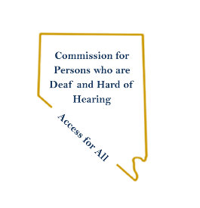
Nevada Commission for Persons who are Deaf and Hard of Hearing
Nevada Department of Health and Human Services
Aging and Disability Services Division
3320 W. Sahara Ave. Suite 100

September 15, 2023
Joe Lombardo
Governor

Dear Potential Conference Supporter,

The Nevada Commission for Persons who are Deaf and Hard of Hearing will be hosting the Engagement Conference 2023 in December of 2023. This conference is the only conference in Nevada being hosted to provide Legislative Advocacy Training for stakeholders and Community partners through a Deaf and Hard of Hearing Lens.
The Nevada Commission for Person who are Deaf and Hard of Hearing or Speech Impaired is seeking to educate and empower individuals who are Deaf and/or Hard of Hearing on Policymaking and Change. This initiative is to impact the potential of stronger presence in the legislative process for the 83rd session in 2025. Our planning committee is looking for financial support to ensure that we can provide necessary support during this conference. Details are included below on the items and amounts we need support for.

Items and Amounts Needed:

- (Up to $10,000) Conference Space and Set Up
- (Up to $2,000) Audio and Visual Services
- (Up to $10,000) Accommodations (including CART) and Interpreters (ASL, Spanish, etc.)
- (Up to $10,000) NVAD Winter Gala Support – Requester NVAD
- (Up to $350) Pens and Notepads
- (Up to $2,500) Program Printing
- (Up to $5,000) Food for Event

If you are able to assist with any of the items listed above in total or in part, please contact Obioma Officer at obioma@adsd.nv.gov or Video Phone Number: (725) 235-3206.

You can view more information about this conference at: https://www.nevadaddcouncil.org/nvdhhcommissionengagementconference2023/

Please note that direct donations of items and payments for services is acceptable. All other donations can be made out to:

Nevada Association of the Deaf (NVAD)
2345 Via Inspirada, Suite 100, #408
Henderson, NV 89044

Please contact our agency for any additional information or questions you may have. We thank you for your consideration to support his conference and we look forward to hosting a fantastic event for this community.

Thank you,

Obioma Officer
Executive Director
Nevada Commission for Persons who are Deaf and Hard of Hearing

