Introduction

The lack of transportation options is a significant barrier hindering many adults with physical and neurological disabilities from living independently. Absent transportation, this vulnerable segment of the population remains unable to maintain employment, receive medical care, attend college, perform errands (going to the grocery store), visit with friends and family, and/or live alone. Access to transportation directly affects the well-being of our neurodivergent and disabled population.

According to the Bureau of Transportation Statistics at the United States Department of Transportation in its 2022 National Travel Survey (NHTS), it estimated that 10.0 million Americans ages 18 to 64 and 7.7 million Americans ages 65 and older had self-reported travel-limiting disabilities. Travel limiting disability means someone having “a temporary or permanent condition or handicap that makes it difficult to travel outside of the home.” It reported these people (1) were less likely to travel, be employed, and live in a household with a vehicle; (2) took fewer trips and cited health problems as the top-most reason for taking fewer trips; (3) lived in a lower income households; and (4) compensated for their disabilities by asking others for rides, limiting travel to daytime, and using rideshare and special transportation services, such as Dial-A-Ride.

In other words, barriers to transportation directly affect the lives of many adults with disabilities and their ability to thrive.

The Administration for Community Living, an operating division of the U.S. Department of Health and Human Services, through its Accessible Transportation Resource Center, identified barriers beyond difficult signage, physical barriers, and the lack of lift-equipped vehicles that impact transportation access by adults with disabilities. Obstacles included lack of paratransit after 5 p.m. or on weekends, high cost of travel, or inaccessible information about the transit systems may also prevent individuals with disabilities from using transportation services.

The Accessible Transportation Resource Center conducted a December 2024 survey and identified common overall themes: (1) multiple transit systems: travel away from home may require coordination of multiple transportation types, making travel more expensive and challenging for those with mobility issues; (2) ridesharing/on-demand rides: despite flexibility, ridesharing costs and limited wheelchair-accessible vehicles remain concerns; (3) system reliability: paratransit reliability is at times challenged due to missed trips, late pick-ups, and the need for advance booking. Fixed-routes lack door-to-door service and the physical barriers of the road, etc. may also be hindrances; (4) multi-modal accessible communication: many riders noted lack in the accessibility and visibility of communication.

Upon conducting a local survey of the Las Vegas Valley (Henderson, City of Las Vegas, and City of North Las Vegas), the results similarly showed the need for transportation options for adults with disabilities. Many families of adults with disabilities have lived in Southern Nevada for more than 10 years with at least 75% of them having at least one (1) adult with autism and/or other disability living in the home. The primary transportation provider is the family and/or caregiver of the adult with autism and/or other disabilities. Survey results also showed that the majority of families/caregivers did not require specialized vehicles for transporting the adult with a disability.

When asked to identify existing transportation concerns of families and/or caregivers of adults with autism and/or other disabilities, the top two (2) concerns included access and safety at 23.08%, the third concern was availability of transportation at 20%, the fourth concern was time spent traveling to and from a designated destination at 16.92% and the last category was cost at 13.85%. Areas of concern regarding existing transportation options for adults with disabilities in the Las Vegas Valley are similar to the concerns expressed at the national level.

/ / /

/ / /

/ / /

/ / /

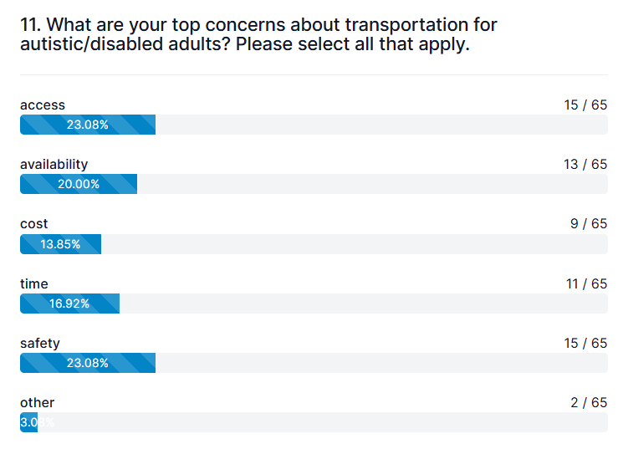
Responses to the survey further demonstrated that families/caregivers under-utilize public transit, TNCs, shuttles, and taxis.

Regarding frequency of use, purpose of travel, and distance, the majority of families/caregivers indicated that their adult with autism and/or other disability needed transportation 4+ days per week for distances requiring travel time of 15+ minutes and for activities encompassing work, medical, school, and recreation.

/ / /

The transportation survey also directly asked adults with autism and/or other disabilities for their input. The majority of survey takers (70%) lived in Southern Nevada for more than 10 years and 19 out of 25 survey takers (76%) had a disability.

Many of the adults with disabilities relied on their families to meet their transportation needs and did not need a specialized vehicle for transport.

Again, survey results showed the under-utilized options of TNCs, shuttles, and taxis. More than 30% of adults with disabilities used public transit.

Out of 67 responses, the top concerns of adults with disabilities included availability at 23.88%, cost at 22.39%, and safety at 20.90%. Access and time were concerns close behind the top three (3).
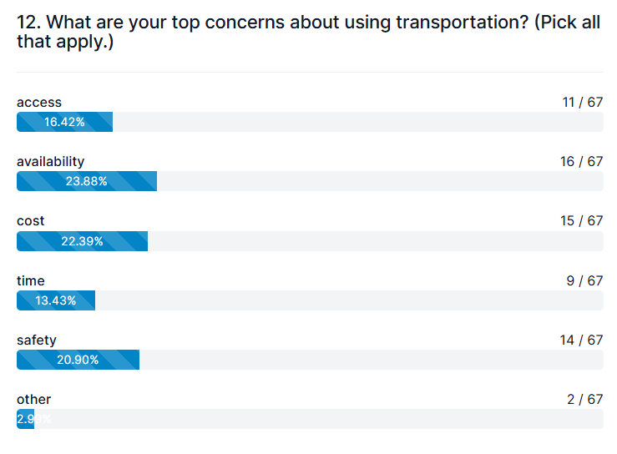
Regarding frequency of use, purpose of travel, and distance, the majority of adults with disabilities needed transportation 1-3 days per week at 34.62% and 4+ days per week at about 30%. Common travel distances had travel times of 15 minutes or less at 28.57%; between 15-30 minutes at 28.57%, and over 30 minutes at 21.43%. Top activities included work (20.31%), recreation/social (21.88%), and medical/therapy (18.75%) with food (15.63%), school (12.50%) and religious reasons (7.81%) following the top three activities. These figures show that adults with disabilities similarly seek lives with balance.

Both national and local transportation results demonstrate the need to create new transportation options that prove sustainable and usable for those that provide it and use it. TRiPs seeks to address this gap in services for adults with disabilities.

Purpose

Despite existing transportation options in the Las Vegas Valley, there still exists a gap for adults with disabilities to access and use transportation responsive to their needs. In response, many private and public businesses and organizations have collectively worked together to identify common challenges faced by our disabled community to access transportation. The purpose is to create a new method of transportation through a supportive network of public and private businesses with local and state governments enabling people with disabilities to get to and from appointments, medical visits, jobs, school, grocery stores, etc. In other words, the purpose is to create something affordable and sustainable for those providing services and for those utilizing them.

Plan

Prior to rolling TRiPS out on a greater scale, TRiPS will begin with 100 adults with disabilities in the Las Vegas Valley as participants in the program. This will allow us to track usage, user and provider responses, identify gaps in service, and manage challenges that arise. Once completed, TRiPS will continue to grow and be introduced incrementally to more adults with disabilities in the Las Vegas Valley. The goal is to not to limit the number of participants nor their usage of multiple ride providers but instead allow riders access to a variety of providers regardless of time, distance, purpose, and/or cost.

Providers will identify their abilities to service disabilities and the location(s) they may serve so that TRiPS can create a “partners footprint,” which will enable providers to “pick up routes” and/or “define routes” to increase service efficiency when providing transportation. In creating a “partners footprint,” multiple providers may network within a defined area or across cities (North Las Vegas, Las Vegas, and Henderson) in filling transportation gaps and/or improving responsiveness in transportation service.

- TIERS of Transportation

The type of transportation will be based upon the independence level (high, medium, low) of the adult with the disability (“rider”) and the volume/how often transportation is needed per week. The available public and/or private service provider (“provider”) may transport for one or multiple independence levels.

For instance, a rider who has a high independence level may take modes of transportation such as transportation network companies (“TNC”), taxis, fixed bus routes and para-transit. Riders who show mid-level or less independence may seek a more specialized form of transportation such as non-emergency medical transport or para-transit.

The goal is to match a rider’s independence level with the appropriate provider so that the ride may be completed successfully. As riders’ independence levels may change, they may seek the providers that best fit their needs at the time.

- Cost of Travel

The cost of travel involving the farthest and shortest typical travel distance within the Las Vegas Valley was used to calculate an average cost of rides. The farthest typical travel distance within Las Vegas Valley (encompassing Las Vegas, Henderson, and North Las Vegas) is approximately 25-30 miles. This usually spans from the far southwest/south Henderson area to the extreme northwest/North Las Vegas area. The shortest most common typical travel distance within Las Vegas Valley may likely be within 10 miles (of a rider’s home). The average cost of travel for 30 miles is $60 one way. The average cost of travel for 10 miles is $40 one way. Based upon these distances, the approximate cost of travel is approximately $50 one way. This along with the limited income of adults with disabilities will help guide the cost of rides for riders and the method to compensate providers.

/ / /

- Payments / Cost

TRiPS strives to make rides cost efficient for disabled riders and seeks to benefit participating providers. Payment options anticipate cashless rides through a computer application and may include a cost per ride and/or a monthly flat fee.

Provider responsibilities will be as follows:
- Each provider will be responsible for providing the necessary ride;
- Each provider will keep its own schedule and calendar;
- Through the app, riders will be accessing the provider’s available time slots and dates (this can be as easy as the app will redirect the rider to the provider’s web page).
- Any changes or update in ride information will be between the rider and the provider.

The app should capture and record the scheduled ride with which provider. This will allow statistics to be gathered to identify what type of transportation is used more frequently, the average distance traveled, and peak hours transportation is needed.

TRiPS anticipates using an “app” to collect money for ride payments, keep track of the number of total rides provided per service provider for the month, may make monthly payments to providers as compensation for participating in TRiPS, and be able to match a rider to provider(s) as needed. The goal of this model is to be affordable and make it easy for both the rider and provider to use.

- Structure

- Coordinating Agency: TRiPS will have a non-profit or a for-profit agency coordinating the issuance of tickets via the “app,” the payment of transportation providers, and the background checks through RTC, a process that already exists. The agency will be responsible for answering questions and for providing instruction and/or information to users and service providers.

- Providers: any providers wanting to join TRiPS may access an application through the agency who will then perform a background check. The provider will bear both the cost of the application and cost of the backcheck. Providers joining TRiPS will commit for a six (6) month period, which automatically renews unless the provider terminates its commitment by providing a 30-day written notice to the agency.

When a provider terminates its commitment to TRiPS, it shall immediately refund any outstanding tickets/credit to a rider for a ride not yet provided. The provider shall also immediately notify the rider of the cancelled ride and the credit returned to the rider’s account. Providers shall not cancel any scheduled rides less than 2 weeks of the date the ride is needed. Providers shall immediately return any TRiPS door magnet it received when accepted into TRiPS upon a provider terminating its participation.

- Termination: The agency or provider may terminate a provider’s participation in TRiPS for any reason by providing a 30-day written notice.

  - Suspension/Termination: The number or percentage of missed rides, untimely ride cancellations, and timeliness/quality of rides provided may affect a provider’s continued participation in TRiPS and may result in suspension and/or termination. The process of provider suspension and/or termination will be governed by an appeals process.

- Background Checks: RTC currently provides a comprehensive background check prior to certifying and partnering with a transportation business. TRiPS will have RTC perform this same check for providers seeking to participate in this program.

- TRiPS Passport: Each rider will input information when booking a ride about his/her individual needs and/or preferences during the ride. For instance, no loud music, request driver explains what to expect during the rider, no conversation, or a rider needs a “warm hand-off,” which means that a driver will need to make sure the rider is left with a person and not on the curb or in front of a building. TRiPS Passport helps to ensure that parties understand what is needed to make the ride successful for the rider and provider.

- Which Riders May Participate?
Adults who are neurodivergent or have other disabilities may participate in TRiPS. The goal is to expand participation and not limit it. TRiPS will accept riders who have any of the following:

- Individualized Education Plan (“IEP”) / Multidisciplinary Team (“MDT”);
- Open or previously closed vocational rehabilitation case;
- Expired or current Paratransit case; or
- Able to show documentation establishing his/her physical and/or mental disability.

- Survey

In addition to tracking the program through the “app,” TRiPS’s progress will be tracked through digital surveys to the providers and the 100 participants/riders at 30 days, 6 months, and 1 year to identify what part of the transportation project is successful, what needs adjustment, and what needs improvement. TRiPS will also have a 24-hour digital drop box for participants and providers to send in their concerns, comments, and/or commendations. Having real-time interaction and accessibility will allow TRiPS to respond and refine its transportation program.

- Vehicle Identification – Identifying Providers

Providers participating in TRiPS will be given door magnets to be easily visible and identifiable by riders.

- Incentives to Riders

Riders will receive TRiPS cards that may be used at local establishments. By showing them this card, riders may receive discounts on items, products, and / or services. Showing local establishments / businesses this card helps confirm that they benefit from having independent adults with autism and other disabilities seek products and/or services from them.

Participation cards will also help encourage local establishments to become involved through money and/or in-kind donations to TRiPS and its participants. For instance, local establishments may run “specials” for TRiPS card holders.

Riders may also benefit from “Hot Deals” where they get rides at a “discount” during “zone times” to encourage usage during slower ride times.

- Incentives to Service Providers and Private/Public Businesses

Providers and/or local businesses may receive incentives by participating in TRiPS. Providers may benefit by being able to buy certain products such as car parts at a discount, receive repairs at a discount or at no labor cost, or buy vehicles at cost. Tax incentives may be sought for businesses employing adults with neurodivergences and/or other disabilities, transportation providers, and businesses supporting TRiPS monetarily and/or in-kind.

Local businesses may receive increased business not only from providers but from friends and families of riders and from riders themselves. Local businesses participating in TRiPS by providing monetary and/or in-kind support will receive a sign to place in their establishment to signify to consumers they are part of TRiPS.

- Education and Communication

TRiPS will be shared with riders, providers, local businesses, and the community. For riders, TRiPS will focus on sharing information with vocational rehabilitation, transition specialists, non-profits, schools, and any programs/services/businesses for individuals with disabilities.

For providers and/or businesses, TRiPS will focus on sharing information with them individually and inviting them to participate.

TRiPS will create a website and establish a social media presence identifying TRiPS, the agency to contact, and specifying how to use and/or provide transportation.

Multi-level education will be required with various audiences and real-time communication will be necessary for riders, providers, and businesses.

Summary

TRiPS model allows for flexibility in creating sustainable transportation for both the riders and providers of transportation for adults with disabilities. TRiPS is about access to transportation and addresses concerns expressed by this community such as accessibility, safety, availability, cost, and time. It anticipates a commingling of transportation options including microtransit, paratransit, medical transport, rideshare, driverless vehicles, private businesses, and /or public organizations. TRiPS calls upon the community to work together to share the responsibilities of providing this transportation. Only through joint efforts can we attain our goal and assist adults with neurodivergences and other disabilities to thrive.

Thank you to our collaborators:
Special Olympics
Opportunity Village / Betty’s Village
Regional Transportation Commission of Southern Nevada (RTC)
General Federation of Women’s Clubs, Henderson Chapter
Vocational Rehabilitation
City of Henderson

Bureau of Transportation Statistics. “Travel Patterns of American Adults with Disabilities.” www.bts.gov, 3 Jan. 2022, www.bts.gov/travel-patterns-with-disabilities.
Id.
Id.
U.S. Dept. of Health and Human Services. “Accessibility Basics | ACL Administration for Community Living.” Acl.gov, 2024, acl.gov/TransportationCenter/AccessibilityBasics.
Id.
“Accessibility Basics/ACL Administration for Community Living.” Acl.gov, 2024, acl.gov/TransportationCenter/AccessibilityBasics, survey-snapshot-december-2024-atrc.pdf
For families/caregivers taking the Transportation Survey, 85% of them lived in Southern Nevada for more than 10 years. 75% of survey takers had an adult with autism and/or other disability living in the home. Autism Cares Survey, March and April 2026.
In 17 out of 20 families, the caregiver and/or family member provided transportation for the adult with autism and/or other disabilities. Autism Cares Survey, March and April 2026. In frequency, 45% of families/caregivers provided 100% of the rides and 40% of families/caregivers provided 50% or more of the rides. Autism Cares Survey, March and April 2026.
19 out of 20 families did not need a specialized vehicle for their adult with autism and/or other disabilities. Autism Cares Survey, March and April 2026.
For shuttles, 18 out of 20 (90%) families did not use this mode of transportation and 2 out of 20 families (10%) used shuttles less than 50% of the time. For taxis, 20 out of 20 families (100%) did not use taxis. For public transit/paratransit, 16 out of 22 families (72.73%) did not use this mode of transportation, 5 out of 22 families (22.73%) used this less than 50% of the time, and 1 out of 22 families (4.55%) used this 50% or more of the time. For TNCs, 17 out of 20 families (85%) did not use TNCs, 2 out of 20 families (10%) used TNCs less than 50% of the time, and 1 out of 20 families (5%) used TNCs 50% or more of the time. Autism Cares Survey, March and April 2026.
Over 50% of caregivers/families indicated that their adults with autism and/or other disabilities required transportation 4-5 days (26.09%) and over 5 days (30.43%). Travel time to locations travelled most often by adults with disabilities included 15 minutes or less (25%), between 15-30 minutes (37.50%), and over 30 minutes (25%). Activity types varied but most popular included work (18.87%), medical (22.64%), school (16.98%), and recreation/social (22.64%). Autism Cares Survey, March and April 2026.
The adults responding to the transportation survey included ages 18-30 (66.67%), 31-40 (8.33%), 41-50 (12. 50%), and over 50 (12. 50%). Autism Cares Survey, March and April 2026.
17 out of 24 (70.83%) lived in So. NV for over 10 years, 4 out of 24 (16.67%) lived in So. NV for 6-10 years, and 3 out of 24 lived in So. NV for 1-5 years (12.50%). Autism Cares Survey, March and April 2026.
62% of the 19 adults with disabilities had family to transport them. Autism Cares Survey, March and April 2026. 95.83% did not require a specialized vehicle (allowing for wheelchairs, scooters, etc.) for transport. Autism Cares Survey, March and April 2026.
17 out of 24 (70.83%) did not use TNCs, 21 out of 25 (84%) did not use shuttles, 22 out of 24 (91.67%) did not use taxis, and 16 out of 24 (66.67%) did not use public transit/paratransit. Over 30% (8 out of 24) used public transit for travel. Autism Cares Survey, March and April 2026.
Calculating the travel cost for 30 miles: 1) a bus ride (including transfers) ($8) , 2) TNC’s (transportation network companies) ($45-$70), 3) cabs ($85-$110), and 4) specialized transportation (those accommodating wheelchairs, etc.) ($65-$75 (sedan/SUV); $105-$125 (wheelchair/ADA van); $165-$210 (stretcher service).
Calculating the travel cost for 10 miles: 1) a bus ride (including transfers) ($2-$8) , 2) TNC’s (transportation network companies) ($15-$30), 3) cabs ($35-$45), and 4) non-emergency medical transport (those accommodating wheelchairs, etc.) ($40-75 (sedan/SUV); $65-$130 (wheelchair/ADA van); $160-$210 (stretcher service).

