Nevada Governor’s Council on Developmental Disabilities
Federal Fiscal Year (FFY) 2025 Annual Report
October 1, 2024 – September 30, 2025

About the Nevada Governor’s Council on Developmental Disabilities
The Nevada Governor’s Council on Developmental Disabilities (NGCDD) is a federally funded, self-governing organization authorized under the Developmental Disabilities Assistance and Bill of Rights Act (DD Act) and established in Nevada Revised Statutes (NRS) 232.320. The Council is housed within the Nevada Health Authority (NVHA) and serves as an independent educator to the Governor, Legislature, policymakers, state agencies, and the broader community on issues impacting individuals with intellectual and developmental disabilities (I/DD).
The Council works to identify the most pressing needs of individuals with I/DD and their families throughout Nevada and supports advocacy, systems change, and capacity building activities that promote self-determination, inclusion, accessibility, equal opportunity, and access to community-based supports and services.
Through collaboration with self-advocates, families, community organizations, state agencies, educators, healthcare providers, and DD Act partners, the NGCDD works to strengthen systems and improve opportunities for individuals with I/DD to fully participate in all aspects of community life.
Throughout FFY 2025, the Council continued expanding statewide outreach, public education, leadership development opportunities, accessibility initiatives, and advocacy efforts. The Council supported projects and activities focused on employment, education, health equity, transportation, community inclusion, emergency preparedness, leadership development, and access to quality services and supports.
The Council also continued prioritizing underserved populations, including rural communities, Hispanic and multilingual communities, individuals who are Deaf or hard of hearing, and individuals with complex communication and accessibility needs. Efforts remained focused on ensuring information, trainings, meetings, and events were accessible through language access, interpretation, Braille, large print, hybrid participation opportunities, and accessible technology supports.
In FFY 2025, the Council supported and participated in numerous statewide and national initiatives, conferences, educational events, advocacy opportunities, and community partnerships aimed at increasing awareness, strengthening self-advocacy, improving systems coordination, and empowering individuals with disabilities and their families.
This annual report highlights the goals, objectives, activities, outcomes, partnerships, and accomplishments achieved during Federal Fiscal Year (FFY) 2025 in alignment with the Council’s 2022–2026 Five-Year State Plan.
Staff and Leadership
NGCDD Staff

- Executive Director: Catherine Nielsen, MPA
- Executive Assistant: Rebecca Ortiz
- Projects Manager: Marisol Rivas
- Self-Advocacy Coordinator: Ellen Marquez
- Public Health Liaison: Kimberly Palma-Ortega
- Intern: Alysa Marquez

Council Leadership
- Chair: Christine Riggi
- Vice Chair: Maxmillian Lowe
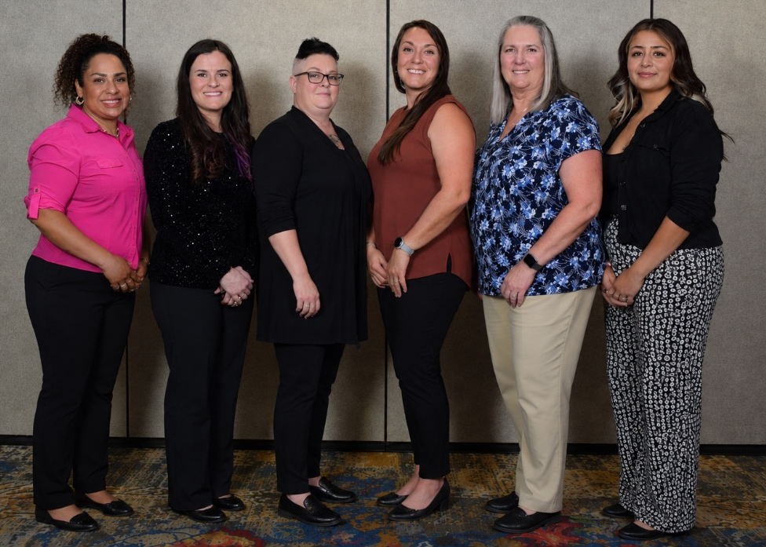
(Featured from left to right: Marisol Rivas, Catherine Nielsen, Kimberly Palma-Ortega,
Christine Riggi, Ellen Marquez, Rebecca Ortiz)

Council Membership

Individuals with I/DD
- Stacy Alaribe
- Max Lowe
- Gabriel Tejada
- Brynlin Thornley
- Vacancy
- Vacancy
- Vacancy

Parents, Family Members, or Guardians of Individuals with I/DD
- Christine Riggi
- Stacy Carlston
- Melissa Bart-Plange
- Anna Marie Binder
- Kathleen Kingston (also representative of individual who previously or currently resides in an institution)
- Vacancy
The Council activity worked on filling the vacancies in the citizen membership positions.
State Agency and Partner Representatives
Representative of Special Education: Individuals with Disabilities Education Act (IDEA):
  - Ashley Price, Office of Inclusive Education, Department of Education
Representative of Vocational Rehabilitation Act of 1973
  - Vivian Turner, Office of Vocational Rehabilitation, Department of Employment, Training, and Rehabilitation
Representative of Aging: Older Americans Act of 1965 (OAA)
  - Autumn Blattman, Aging and Disability Services Division, Department of Health and Human Services
Representative of Maternal and Child Health Program: Title V of Social Security Act (SSA)
  - Vickie Ives, Child, Family and Community Wellness, Department of Health and Human Services
Representative of Medicaid: Title XIX of Social Security Act (SSA)
  - Ellen Frias-Wilcox, Division of Health Care Financing and Policy, Department of Health and Human Services
Representative of Protection and Advocacy Agency (P&A)
  - Kate Osti, Nevada Disability Advocacy and Law Center
Representative of University Center for Excellence on Developmental Disabilities (UCEDD)
  - Randall Owen, Nevada Center for Excellence in Disabilities, University of Nevada, Reno
Representative of a Local or non-governmental agency concerned with services for people with developmental disabilities.
  - Lisa Bonie, Northern Nevada Center for Independent Living
Representative of Private, non-profit group concerned with services for people with developmental disabilities.
  - Taylor Chaney, The Garden Foundation, Las Vegas, Nevada

FFY 2025 Overview
Throughout FFY 2025, the Nevada Governor’s Council on Developmental Disabilities continued to expand statewide outreach, advocacy, systems change efforts, and leadership development opportunities for individuals with intellectual and developmental disabilities (I/DD) and their families. Through collaboration, education, and community engagement, the Council worked to strengthen systems of support, increase opportunities for meaningful inclusion, and elevate the voices of individuals with lived experience throughout Nevada.
The Council worked collaboratively with self-advocates, families, community organizations, state agencies, DD Act partners, educators, healthcare providers, service systems, and policymakers to increase access to information, strengthen advocacy skills, improve community inclusion, and support innovative approaches to services and supports. These efforts included public awareness campaigns, statewide trainings, leadership development initiatives, policy education, technical assistance, coalition building, and participation in statewide and national discussions impacting individuals with I/DD.
Throughout the year, the Council supported opportunities for individuals with I/DD and family members to actively participate in decision-making processes, leadership roles, advisory groups, committees, conferences, and systems change activities. The Council also continued efforts to improve access to plain language information, accessible materials, language interpretation, and culturally responsive outreach to ensure more individuals and families could meaningfully engage in available programs, services, and advocacy opportunities.
Activities completed during FFY 2025 aligned with the Council’s Five-Year State Plan goals in the areas of:

- Employment
- Education
- Health
- Transportation
- Housing
- Quality Assurance
- Community Supports
- Self-Advocacy and Leadership Development

The Council continued to prioritize outreach to underserved and rural communities, recognizing the unique barriers many individuals and families face in accessing services, supports, healthcare, transportation, housing, and employment opportunities. Efforts were made to increase statewide representation and participation from diverse communities through virtual and in-person engagement opportunities, regional outreach efforts, partnerships with local organizations, and accessible communication strategies.
In FFY 2025, the Council also focused on strengthening partnerships across Nevada’s developmental disabilities network and broader disability community to support long-term systems change. This included collaborating with DD Act partners, advocacy organizations, healthcare systems, educational institutions, policymakers, and community-based organizations to identify emerging needs, address gaps in services, and improve coordination across systems.
Additionally, the Council supported initiatives designed to increase self-determination, independence, and leadership opportunities for individuals with I/DD. Through trainings, conferences, youth and adult leadership development programs, self-advocacy initiatives, and peer engagement opportunities, individuals with I/DD were supported in building skills to advocate for themselves, participate in their communities, and influence policies and systems that impact their lives.
The Council remains committed to promoting equal opportunity, independence, productivity, self-determination, and inclusion for all Nevadans with developmental disabilities while continuing to advance systems change efforts that improve the quality of life for individuals with I/DD and their families statewide.

Goal 1: Informed Choices
Goal Statement
The NGCDD will work towards ensuring that individuals with I/DD and/or family members of individuals with I/DD are able to make more informed decisions about their lives by improving access to information on services, supports, and rights.
FFY 2025 Highlights
Public Education and Outreach
During FFY 2025, Council members and staff participated in public education and outreach activities aimed at increasing awareness of disability services, rights, supports, and community resources available throughout Nevada.
Activities included:

- Lunch and Learn webinar series
- Resource fairs and community events
- Educational presentations
- Distribution of informational materials
- Website accessibility improvements
- Community outreach efforts
- Collaboration with statewide committees and coalitions

Accessibility and Information Access
The Council continued efforts to improve accessibility of information and communication through:

- ASL interpretation
- Spanish translation
- Large print materials
- Braille materials and printing support
- Website accessibility features
- Language access supports

The Council also continued utilizing accessibility tools and virtual platforms to reduce barriers for individuals and families accessing information remotely.
Community Collaboration
Council members and staff participated in numerous statewide committees, coalitions, advisory groups, and community partnerships focused on improving systems and services for individuals with disabilities.
Collaborative efforts supported:

- Information sharing
- Interagency coordination
- Public awareness
- Emergency preparedness
- Health and wellness initiatives
- Inclusive community participation

Conferences, Events, and Public Engagement
Council staff and members attended and participated in conferences, trainings, resource fairs, and statewide community events focused on disability advocacy, education, inclusion, and systems change.
Disability Policy Seminar – April 2025
The Executive Director attended the 2025 Disability Policy Seminar in Washington, D.C., in April 2025, alongside Casey Melvin, CEO, and BreeAnnda Melvin, Administrative Director from Tilton’s Mobile Therapy, to help elevate community concerns related to disability services, therapy access, healthcare barriers, and workforce challenges impacting Nevadans with disabilities.
During the seminar, the Occupational Therapists shared firsthand experiences regarding the challenges families and providers face in accessing and maintaining therapy services, including concerns related to reimbursement, provider shortages, service accessibility, and continuity of care. These conversations provided policymakers and congressional staff with valuable insight into the real-world impacts current systems and policies have on individuals with disabilities and the professionals supporting them.
Participation in the Disability Policy Seminar also provided opportunities for collaboration with national disability organizations, education on federal policy issues, and engagement with Nevada’s congressional delegation regarding issues impacting individuals with I/DD and their families.
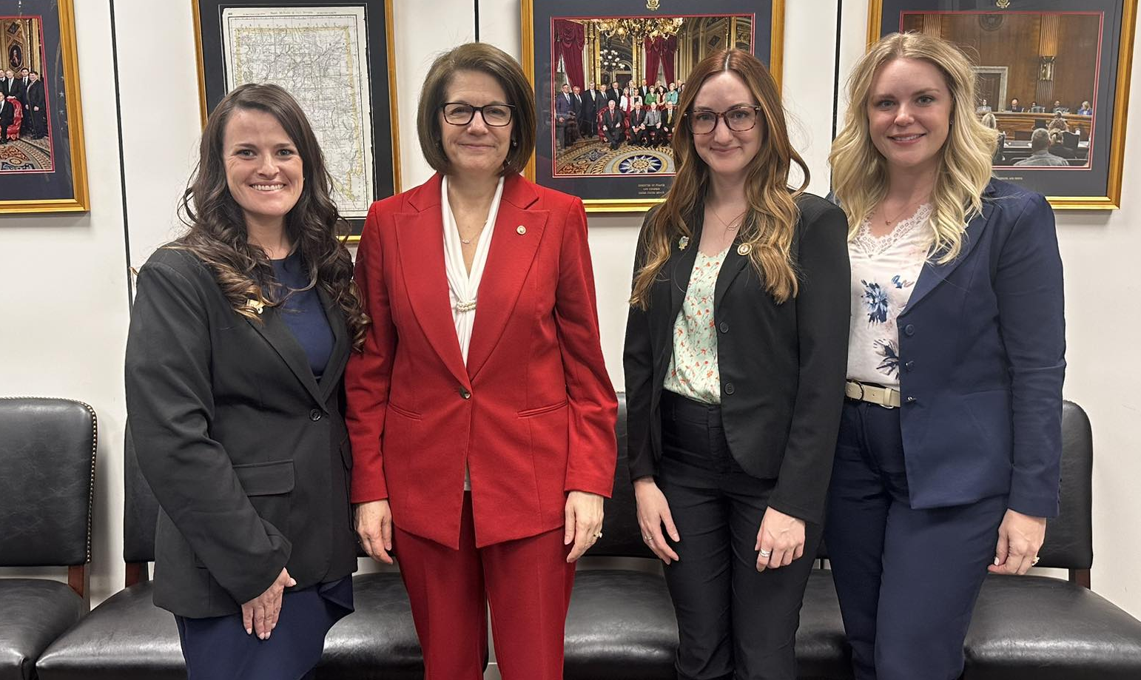
(Pictured from left to right: Catherine Nielsen, Senator Catherine Cortez Masto – Nevada,
BreeAnnda Melvin – Tilton’s Mobile Therapy, and Casey Melvin – Tilton’s Mobile Therapy)

Deaf Day at the Legislature – April 28, 2025
The Council provided $8,000 in funding support for Deaf Day at the Legislature 2025. Travel and event participation activities occurred between April 27–29, 2025. This event provided opportunities for members of the Deaf and hard of hearing community to engage directly with legislators, participate in advocacy activities, and increase awareness regarding accessibility and disability-related issues impacting Nevadans.
Outcomes:

- 133 individuals registered
- 20 onsite registrations completed
- 109 individuals participated from preregistration
- 9 vendor booths participated
- 4 legislators attended or stopped by the event
- 32 legislative lobby visits were scheduled, each hosting approximately 2–4 community members

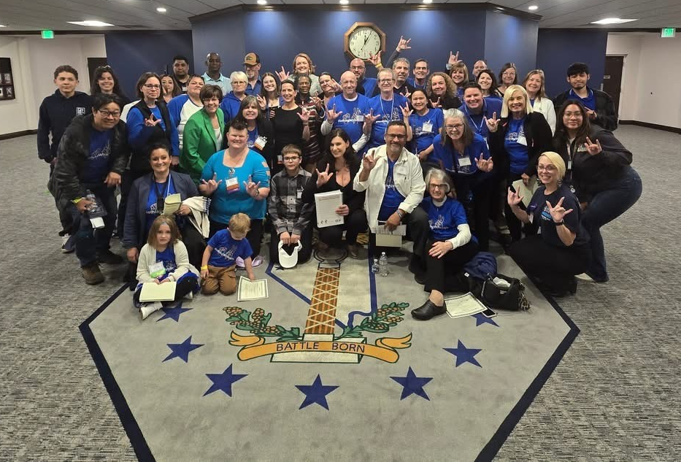
(Pictured are children and adults from Nevada who are Deaf, Hard of Hearing and Speech Impaired. Also pictured are their family and friends alongside Assemblywoman Tracy Brown-May, in the State of Nevada Legislative Building during Deaf Day 2025.)
Deaf Engagement Conference 2024 – December 13–14, 2024
The Council provided $40,700 in funding support for the Deaf Engagement Conference 2024. The conference focused on community engagement, education, leadership development, accessibility, and strengthening connections within Nevada’s Deaf and hard of hearing community.
Outcomes:
- 156 participants who were deaf/hard of hearing, family members, and professionals attended
- 25 vendor booths participated
- 1 legislator attended the event
Emmy Award Recognition – June 22, 2025
On June 22, 2025, members of Nevada’s disability community were recognized at the Emmy Awards in San Diego, California, for the film Our World in Our Words, which highlighted disability awareness, advocacy, accessibility, and the lived experiences of individuals and families impacted by disabilities and complex medical conditions.
The film received Emmy Awards in the following categories:

- Audio Recording, Mixing, and Design
- Editing – Long Form Content
- Photography – Long Form Content
- Diversity, Equity, and Inclusion
This recognition helped elevate public awareness regarding disability-related issues and highlighted the importance of authentic storytelling, community representation, and inclusion in media. The recognition also provided an opportunity to increase visibility of Nevada’s disability community and the experiences of individuals with disabilities and their families.
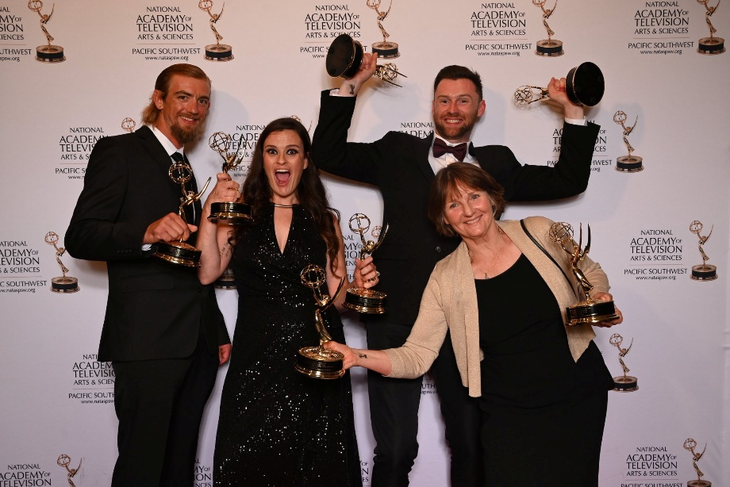
(Pictured from left to right: Matthew Nielsen – husband of Catherine Nielsen,
Catherine Nielsen, and staff from Mountain Dog Media)
Goal 2: Self-Advocacy and Leadership Development
Goal Statement
The NGCDD Staff and Members ensured individuals with I/DD have the information, education, and training necessary to participate in local and state advocacy and policymaking activities.
FFY 2025 Highlights
Partners in Policymaking
The Council continued implementation of Nevada Partners in Policymaking, a nationally recognized leadership development program for self-advocates and family members. Through monthly training sessions, participants learned about disability rights, public policy, person-centered practices, education, employment, healthcare, housing, and effective advocacy strategies. The program helped participants build leadership skills, increase self-confidence, and develop the knowledge needed to advocate for themselves and others. Participants also had opportunities to connect with disability leaders, policymakers, and community organizations, helping to build a stronger network of advocates across Nevada.
Topics included:

- Disability history and rights
- Self-determination
- Supported decision-making
- Education and transition services
- Public policy and legislation
- Community organizing
- Board and committee participation
- Advocacy skills

Leadership and Advocacy Opportunities
The Council supported opportunities for individuals with I/DD and family members to engage in leadership and advocacy activities throughout the year. Participants were encouraged to serve on committees, attend public meetings, provide public comment, and participate in discussions on issues impacting the disability community. The Council also provided information and resources related to legislative issues, public policy, and systems change efforts. These experiences helped individuals gain a better understanding of how decisions are made and how they can influence policies that affect their lives and communities.
Promoting Self-Advocacy
Throughout FFY 2025, the Council continued to promote self-advocacy by providing information, resources, and training opportunities that empowered individuals with disabilities to have a voice in decisions affecting their lives. By supporting leadership development, peer learning, and community engagement, the Council helped strengthen Nevada's network of self-advocates and family leaders working to improve services, supports, inclusion, and opportunities for people with I/DD throughout the state.
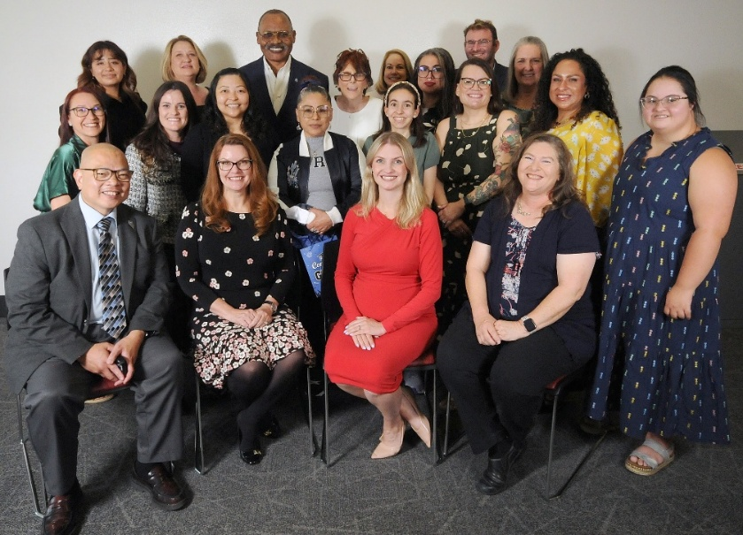
(Pictured are the 2025 NGCDD Partners in Policymaking Graduates, NGCDD Staff and Current/Former Council members, and representatives from Governor Lombardo’s Office, Senator Melanie Schieble, and former Assemblywoman Michelle Gorelow)
Developmental Disabilities Awareness Day at the Legislature – March 3 & 4, 2025
The Council hosted the Developmental Disabilities Awareness Day at the Legislature bringing together over 120 self-advocates, family members, community organizations, policymakers, service providers, educators, and state agencies to raise awareness and celebrate the contributions of individuals with intellectual and developmental disabilities throughout Nevada.
The event focused on:

- Community inclusion
- Self-advocacy
- Disability awareness
- Public education
- Access to services and supports
- Leadership and empowerment
- Community resources
- Collaboration across systems

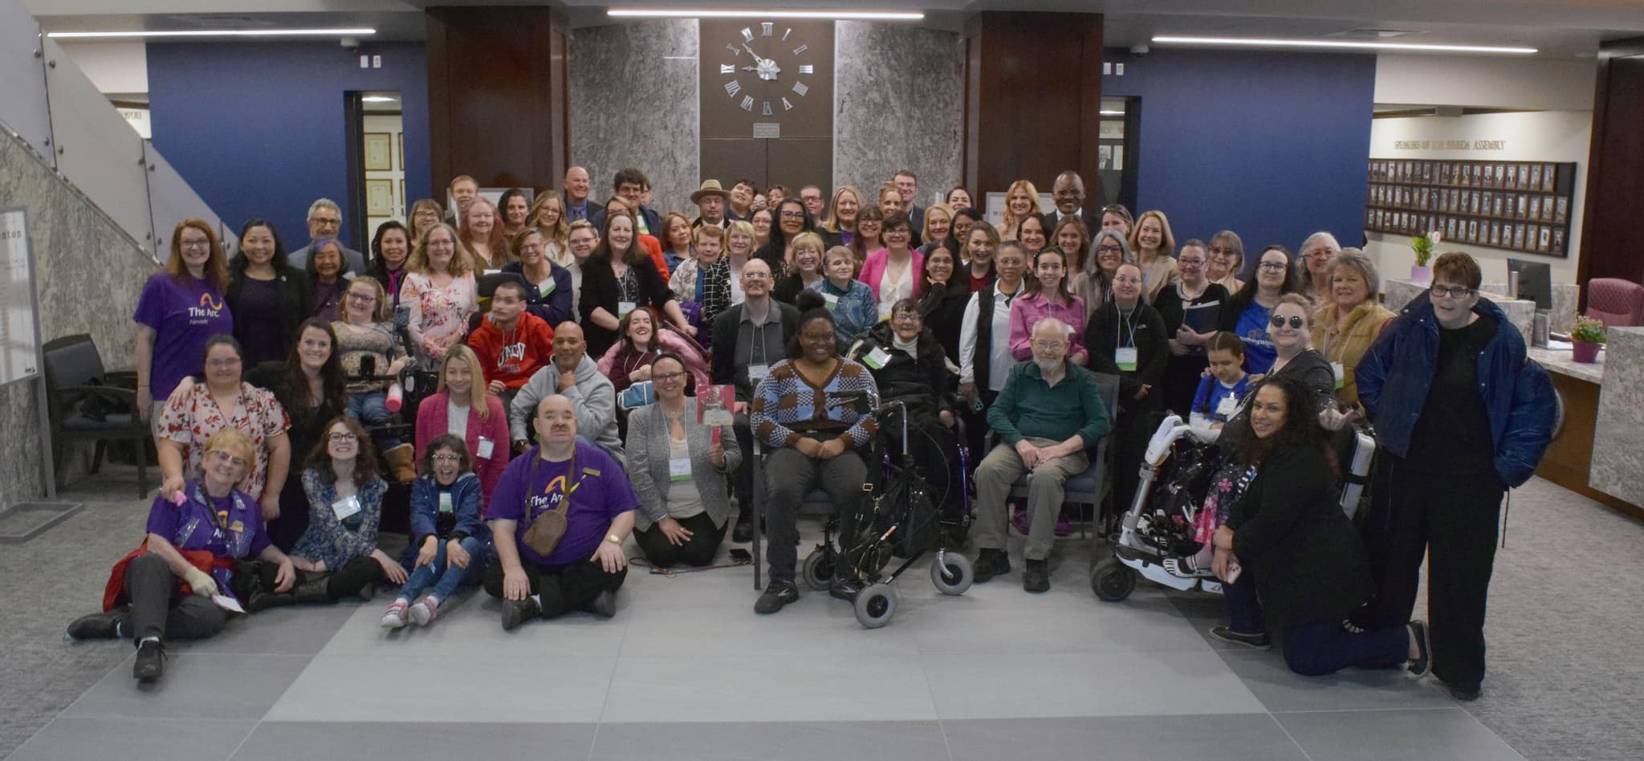
(Pictured are self-advocates, family members, and professionals from the I/DD community across Nevada in the Nevada State Legislature lobby during the Developmental Disabilities Awareness Day event 2025.)
Consumer Leadership Development Fund (CLDF)
The Council continued supporting self-advocates and family members through the Consumer Leadership Development Fund, assisting individuals in attending conferences, trainings, workshops, and other leadership development opportunities that strengthen advocacy skills and knowledge. Through this funding, participants were able to gain valuable information on disability rights, public policy, self-advocacy, leadership, and systems change while building connections with peers and disability leaders from across Nevada and the nation. These opportunities helped individuals increase their confidence, expand their networks, and develop the skills necessary to effectively advocate for themselves, their families, and their communities. The Council remains committed to investing in emerging leaders and ensuring individuals with lived experience have meaningful opportunities to participate in decision-making and advocacy efforts.

- The National Down Syndrome Society Conference in DC
- The Arc National Conference
- Disability Policy Seminar
- Aktion Club Annual Conference
- Chromosome 18 Registry and Research Conference
- Hands and Voices 20th Annual Conference
- Angelman Syndrome Family Conference

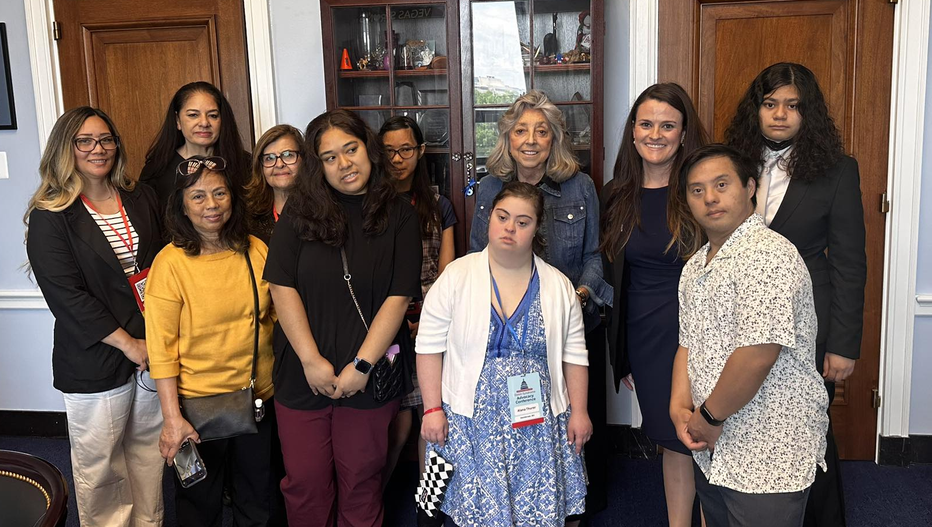
(Pictured are self-advocates and family members from Nevada,
Congresswoman Dina Titus, and Catherine Nielsen)
Support of Self-Advocacy Organizations
The Council continued providing support to self-advocacy organizations and community groups across Nevada through technical assistance, resources, training opportunities, and collaboration.
Support was provided to organizations including:

- Down Syndrome Organization of Southern Nevada
- Las Vegas Deaf Seniors
- Milestone Family Solution
These partnerships helped strengthen community engagement, peer support, leadership development, advocacy opportunities, and access to information and resources for individuals with disabilities and their families throughout Nevada. Through collaboration with community organizations, the Council supported programs that provided individuals with disabilities opportunities to build skills, develop relationships, increase self-confidence, and participate more fully in their communities.
Programs and activities supported through these partnerships included opportunities for individuals with disabilities to participate in:
• Cooking classes that promoted independence, nutrition awareness, and daily living skills
• Dance and movement classes that encouraged physical activity, self-expression, and social interaction
• Art classes and creative expression activities that fostered creativity, confidence, and communication
• Self-advocacy and leadership development classes that strengthened participants' ability to speak up for themselves and influence decisions affecting their lives
• Budgeting and financial literacy education that supported financial independence and informed decision-making
• Writing and communication skill development activities that enhanced self-expression and advocacy skills
• Computer and technology skills training that increased digital literacy and access to information and resources
• Public speaking and confidence-building activities that helped participants develop leadership skills and effectively share their experiences and perspectives
These activities promoted independence, social connection, self-confidence, communication skills, community participation, and increased opportunities for individuals with disabilities to advocate for themselves and others. They also helped participants build meaningful relationships, gain new experiences, and develop the skills needed to become active members and leaders within their communities.
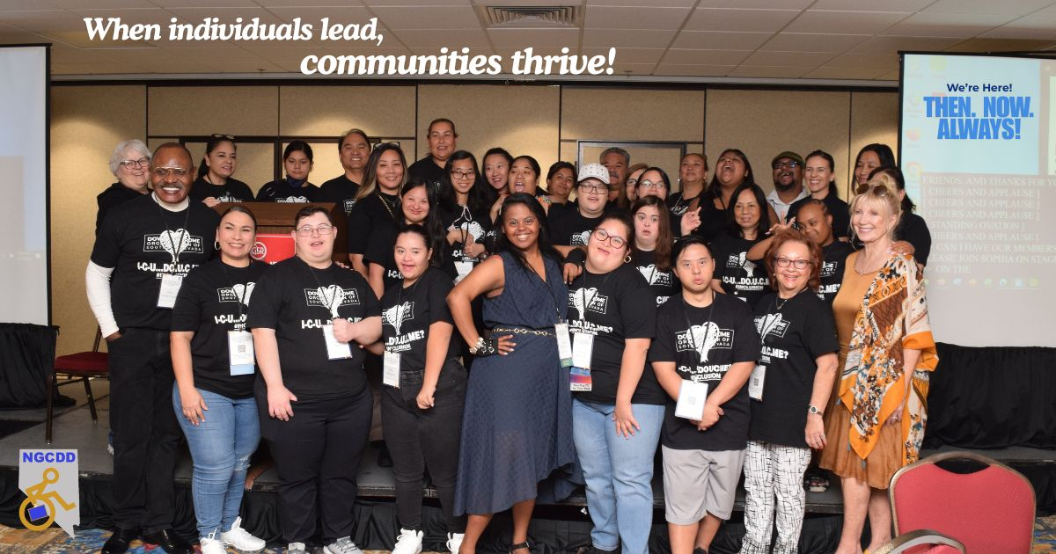
(Pictured are self-advocates and family members from the Down Syndrome Organization of Southern Nevada.)
Goal 3: Systems Change and Access to Quality Services
Goal Statement
The NGCDD Staff and Members worked towards developing and strengthening systems that improve quality services and access to quality services and supports for individuals with I/DD and their families.
FFY 2025 Highlights
Transportation and Community Inclusion
The Council continued supporting transportation and recreation initiatives that increased independence, inclusion, and participation in community life for individuals with disabilities.
Employment Initiatives
Employment-focused projects continued to increase awareness of competitive integrated employment opportunities and best practices for supporting individuals with I/DD in the workforce.
Transition Services and Lifespan Supports
The Council continued supporting transition-focused activities and educational resources related to:

- Post-secondary education
- Employment
- Independent living
- Self-advocacy
- Community participation
- Adult services and supports

Community Needs Assessment and Public Input
The Council continued gathering statewide input through:

- Town halls
- Community surveys
- Stakeholder engagement
- Public comment
- Community meetings

Information gathered through these activities will help inform the development of the next Five-Year State Plan.
DD Act Collaboration and Partnerships
The Nevada Governor’s Council on Developmental Disabilities continued strong collaboration with DD Act partners and statewide agencies throughout FFY 2025.
Collaborative partners included:

- Nevada Center for Excellence in Disabilities (NCED)
- Nevada Disability Advocacy and Law Center (NDALC)
- Nevada Health Authority (NVHA)
- Nevada Medicaid
- Nevada Department of Education
- Nevada Division of Emergency Management
- The Down Syndrome Organization of Southern Nevada
- Sammy’s Den
- Las Vegas Deaf Seniors
- Legal Aid Center of Southern Nevada
- Nevada Legal Services
- Community-based organizations
- Self-advocacy organizations
- Local and national disability organizations

These collaborations strengthened statewide coordination, information sharing, systems improvement efforts, and public education activities.
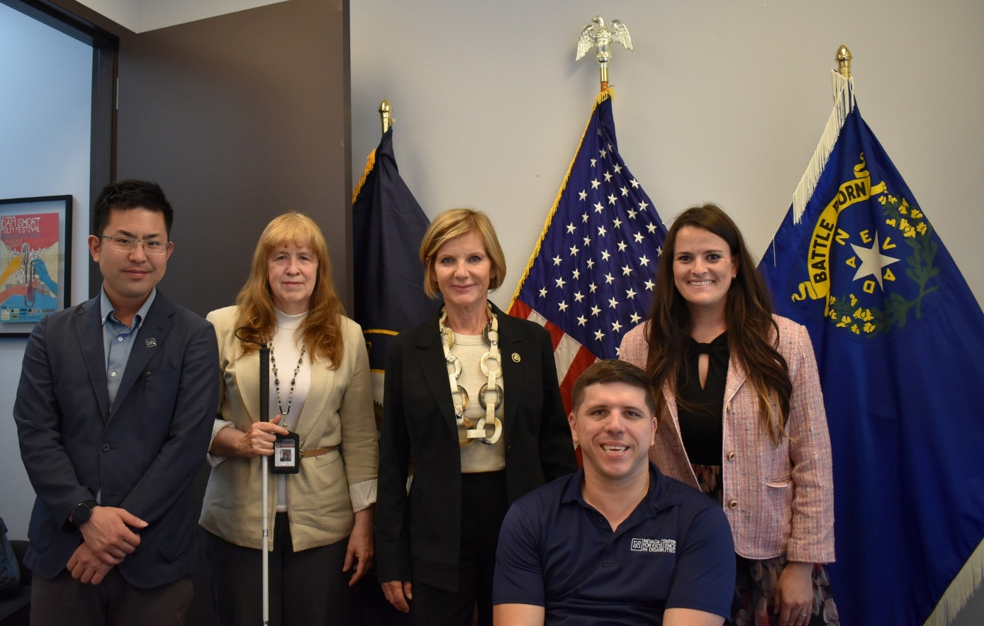
(Pictured from left to right: NV Lend graduate, Kate Osti – Executive Director, NDALC, Congresswoman Susie Lee, Randall Owen - Executive Director, NCED, and Catherine Nielsen)
Accessibility and Inclusion Efforts
The Council remained committed to ensuring accessibility and inclusion across all Council activities, meetings, trainings, conferences, and public outreach efforts.
Accessibility supports included:

- ASL interpretation
- Spanish interpretation and translation
- Large print materials
- Braille materials and Braille printing offered to State of Nevada organizations
- Website accessibility supports
- Hybrid and virtual participation options
- Accessible meeting and conference spaces

These efforts helped reduce barriers and increase access to information, services, and participation opportunities for individuals with disabilities and their families.
Looking Ahead
As the Council moves into FFY 2026 and prepares for the next Five-Year State Plan cycle, the NGCDD remains committed to advancing advocacy, systems change, capacity building, and community inclusion efforts throughout Nevada.
The Council will continue prioritizing:

- Self-advocacy
- Leadership development
- Employment opportunities
- Health equity
- Inclusive education
- Housing and transportation access
- Rural outreach
- Accessibility and language access
- Public policy education
- Community engagement

The Nevada Governor’s Council on Developmental Disabilities appreciates the continued collaboration and partnership of individuals with I/DD, family members, community organizations, state agencies, policymakers, and advocates working together to improve the lives of Nevadans with developmental disabilities.

Contact Information
Nevada Governor’s Council on Developmental Disabilities
406 E Second Street
Carson City, NV 89701
(775) 684-8619
Website: www.nevadaddcouncil.org

